

**Woodward Columnar Juniper**

*Juniperus scopulorum* ‘Woodward*’*

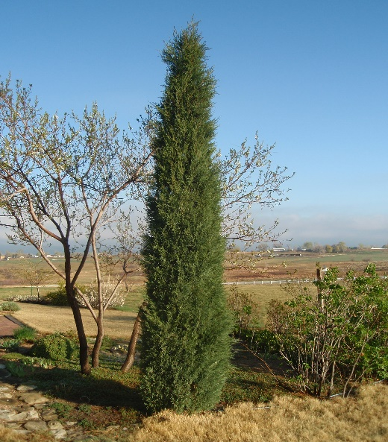

**Height: 20 ft. Width: 3-4 ft.**

This elegant upright evergreen flaunts soft-textured, dark green foliage which turns grey-blue in winter. Its erect stature resists windy conditions and sheds snow with grace. This easy-care, Rocky Mountain native makes a great living privacy fence.

**Culture:** Clay, loam, or sandy soil

**Hardiness:** USDA zones 3-9



WIND. HAIL. SNOW. SUN

**BRING IT ON**

www.plantselect.org

