
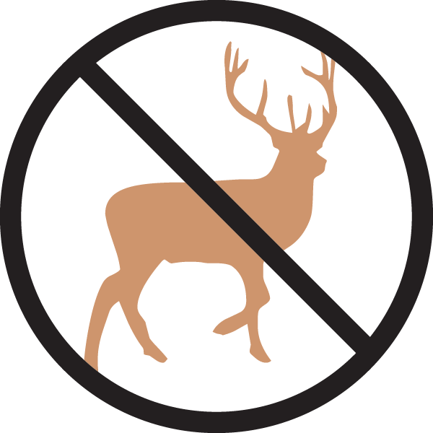

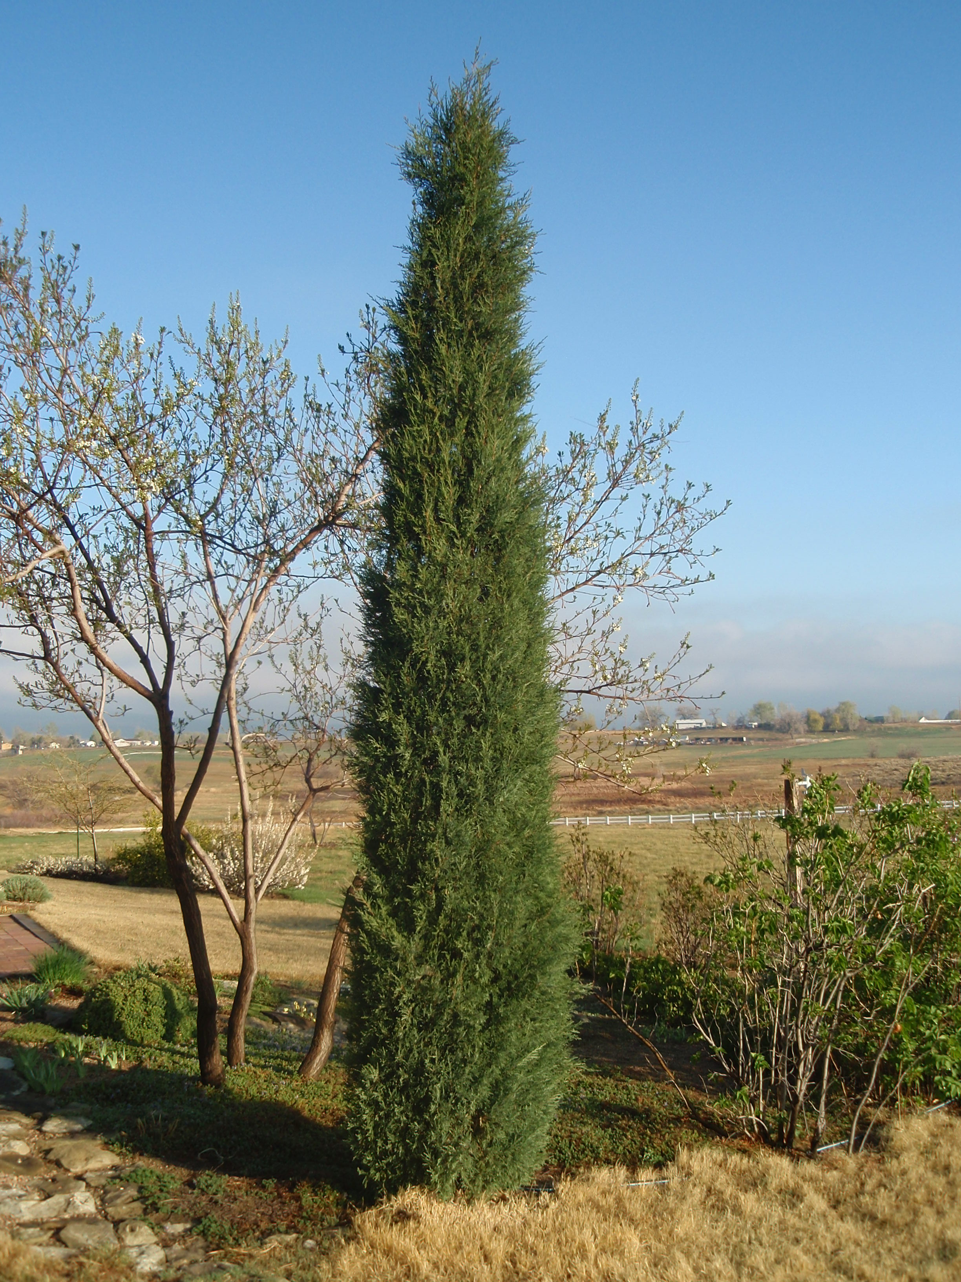
Height: 20’
Width: 2-4’
Sun: Full sun to part shade
Water: Moderate to dry
Hardiness: USDA zones 3-9
Culture: Clay, loam or sand
Recommended: 2015
Conifer
This elegant upright evergreen flaunts soft-textured, dark green foliage which turns grey-blue in winter. Its erect stature resists windy conditions and sheds snow with grace. This easy-care, Rocky Mountain native makes a great living privacy fence, or can be used to punctuate your garden with a living exclamation point!

Woodward Columnar Juniper
Juniperus scopulorum ‘Woodward’
www.plantselect.org

