



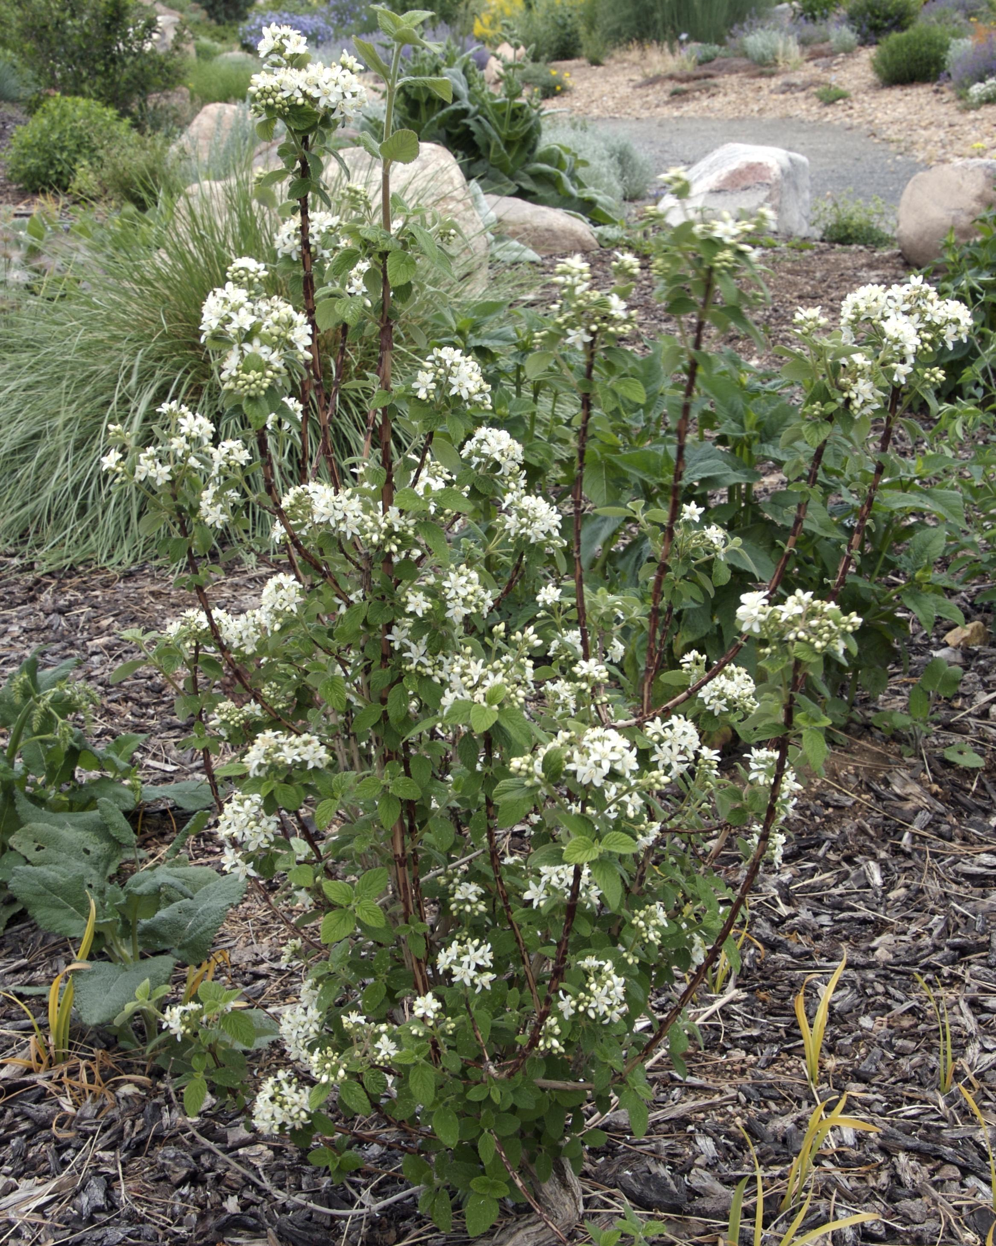
Height: 3-6’
Width: 4-6’
Blooms: May to June
Sun: Partial shade to shade
Water: Moderate
Hardiness: USDA zones 3-8
Culture: Garden loam to gravelly soil; well-drained
Introduced: 2003
Shrub
Intensely fragrant and showy clusters of waxy white flowers appear in late spring on this shrub, with the added interest of flaking reddish-brown bark. Heavy-textured, green foliage transforms to brilliant orange and pink tones in the autumn. This western native adds winter interest with its silvery silhouette. An excellent choice for dry conditions.

Waxflower
Jamesia americana
www.plantselect.org

