
Waxflower
Jamesia americana

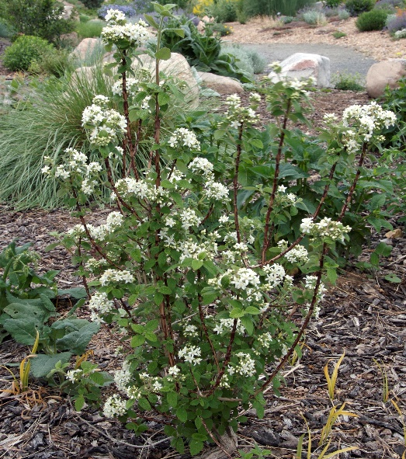







Height: 4-6 ft. Width: 4-6 ft.
Intensely fragrant and showy clusters of waxy white flowers appear in late spring on this shrub, with the added interest of flaking reddish-brown bark. Heavy-textured, green foliage transforms to brilliant orange and pink tones in the autumn. This western native adds winter interest with its silvery silhouette.
Culture: Gravelly or loam soil
Hardiness: USDA zones 3-8



WIND. HAIL. SNOW. SUN
BRING IT ON

www.plantselect.org



