

**Waxflower**

*Jamesia americana*

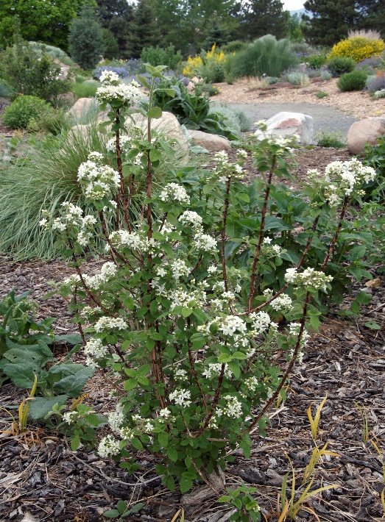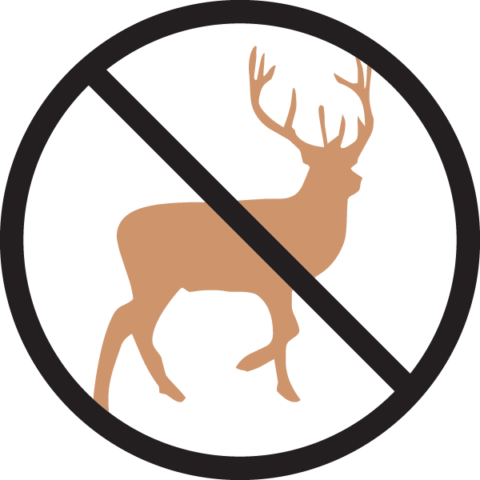

**Height: 4-6 ft. Width: 4-6 ft.**

Intensely fragrant and showy clusters of waxy white flowers appear in late spring on this shrub, with the added interest of flaking reddish-brown bark. Heavy-textured, green foliage transforms to brilliant orange and pink tones in the autumn. This western native adds winter interest with its silvery silhouette.

**Culture:** Gravelly or loam soil

**Hardiness:** USDA zones 3-8



WIND. HAIL. SNOW. SUN

**BRING IT ON**

www.plantselect.org

