



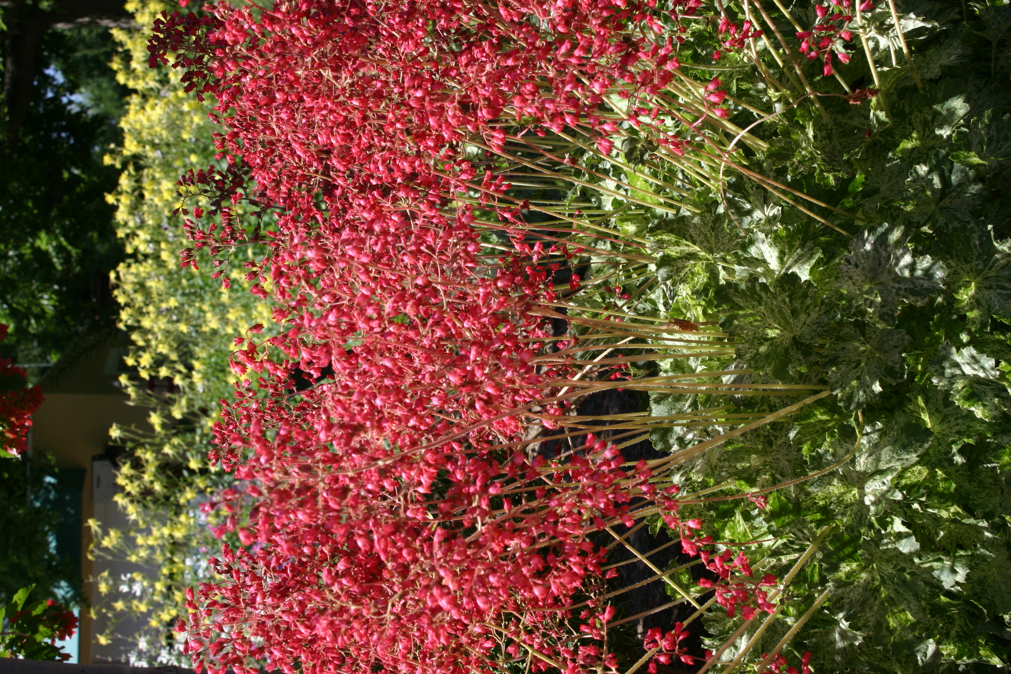
Height: 6” foliage, 12-15” flower
Width: 10”
Blooms: Late spring into summer
Sun: Partial sun to shade
Water: Moderate to xeric
Hardiness: USDA zones 3-9
Culture: Garden loam to gravelly soil
Introduced: 2003
Perennial
Low-growing mounds of light green, broadly-lobed leaves are marbled with a light cream variegation that brightens shady gardens. Spikes of pinkish-red bells add a complimentary note from late spring into summer. An excellent plant for dry shade.

Snow Angel Coral Bells
Heuchera sanguinea ‘Snow Angel’
www.plantselect.org

