
Snow Angel Coral Bells
Heuchera sanguinea ‘Snow Angel’

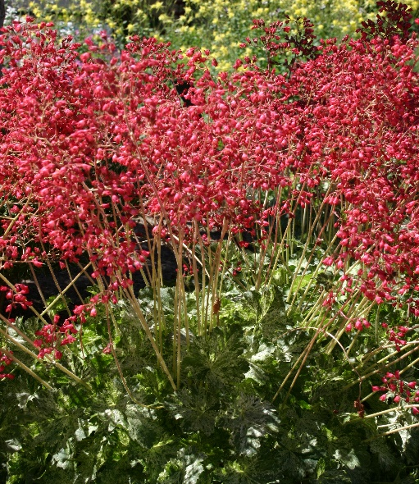






Height: 6 in. foliage, 12-15 in. flower Width: 10 in.
Low-growing mounds of light green, broadly-lobed leaves are marbled with a light cream variegation that brightens shady gardens. Spikes of pinkish-red bells add a complimentary note from late spring into summer. An excellent plant for dry shade.
Culture: Gravelly or loam soil
Hardiness: USDA zones 3-9



WIND. HAIL. SNOW. SUN
BRING IT ON

www.plantselect.org



