

**Snow Angel Coral Bells**

*Heuchera sanguinea* ‘Snow Angel’

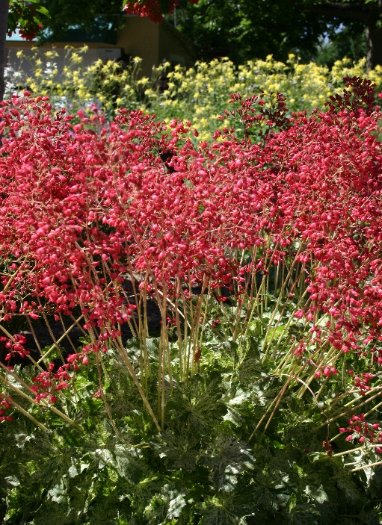

**Height: 6 in. foliage, 12-15 in. flower Width: 10 in.**

Low-growing mounds of light green, broadly-lobed leaves are marbled with a light cream variegation that brightens shady gardens. Spikes of pinkish-red bells add a complimentary note from late spring into summer. An excellent plant for dry shade.

**Culture:** Gravelly or loam soil

**Hardiness:** USDA zones 3-9



WIND. HAIL. SNOW. SUN

**BRING IT ON**

www.plantselect.org

