
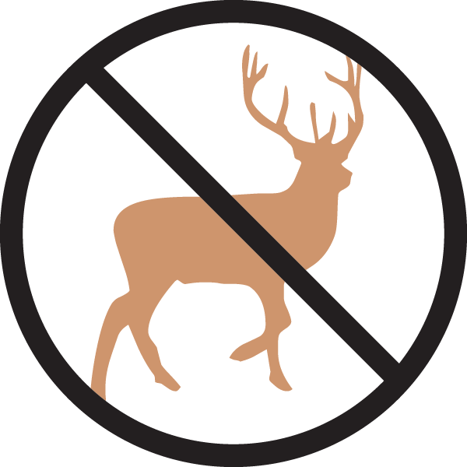


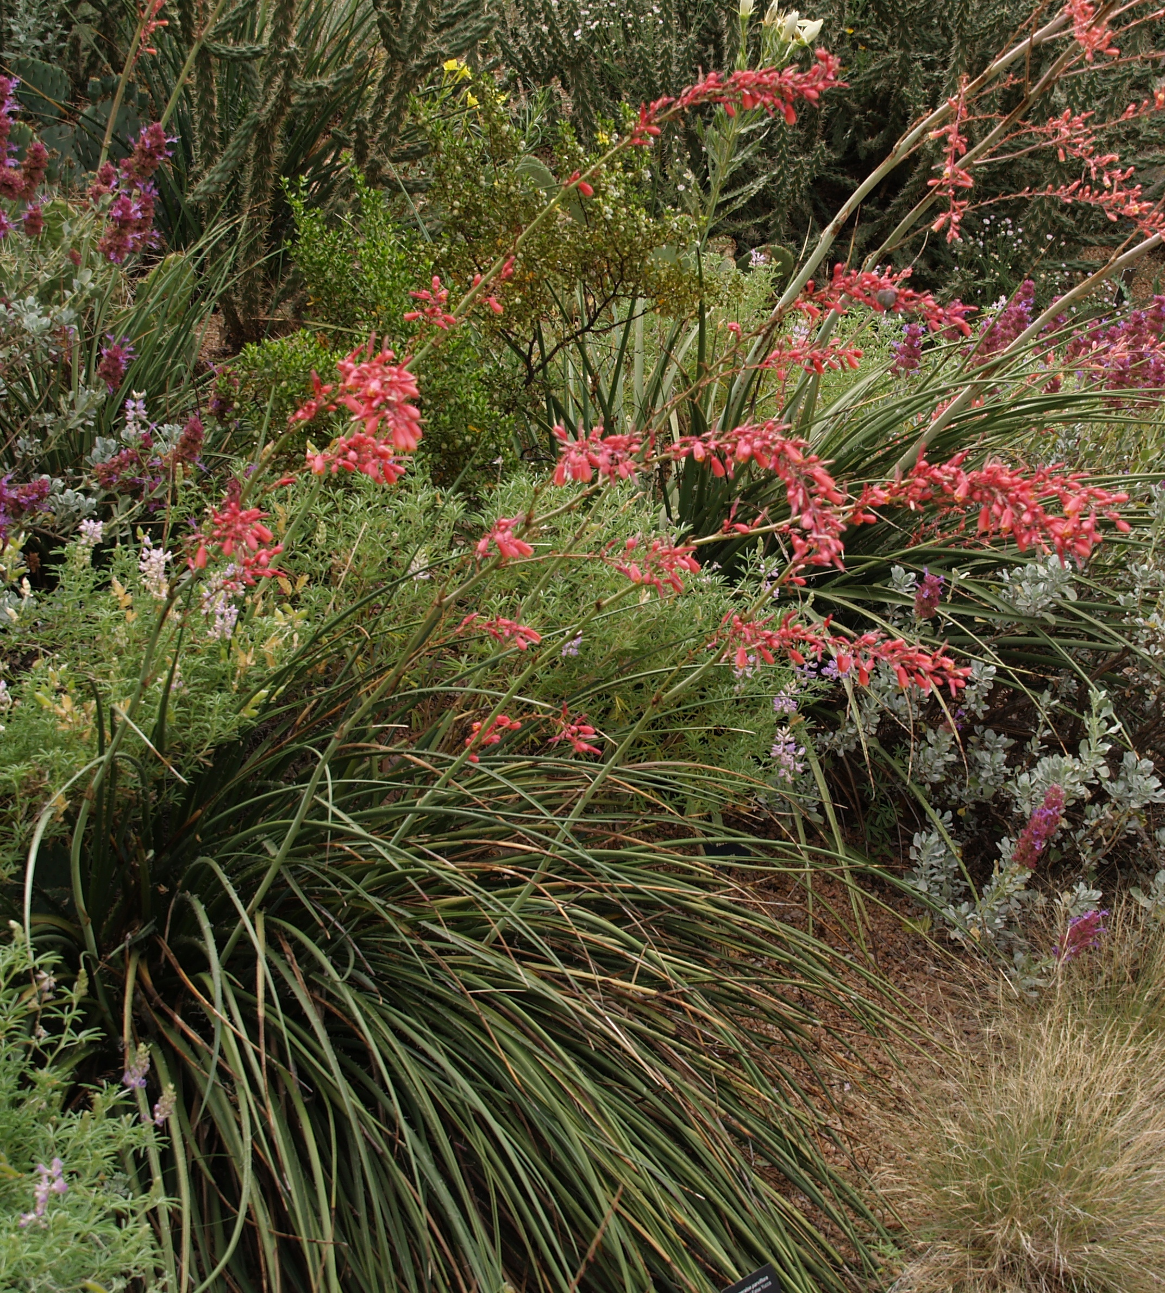
Height: 3-4’
Width: 3-4’
Blooms: June to autumn
Sun: Full sun
Water: Dry; xeric
Hardiness: USDA zones 5-10 (up to 5,800’)
Culture: Lean and dry; well-drained
Introduced: 2010
Woody Perennial
This graceful native of Texas and Mexico has arching, evergreen grass-like leaves with captivating curly white filaments. Tall spikes of brilliant rose-pink, yellow-throated tubular blossoms curve skyward with elegance and are an instant magnet for hummingbirds from early summer to autumn. Red yucca is virtually maintenance-free and perfectly xeric once established.

Red Yucca
Hesperaloe parviflora
www.plantselect.org

