
Red Yucca
Hesperaloe parviflora

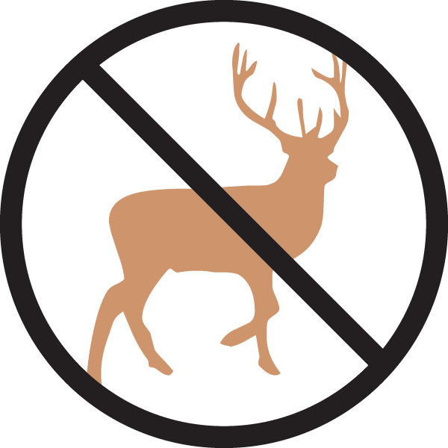




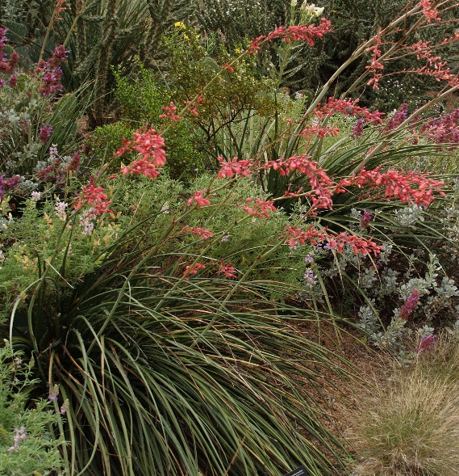

Height: 3-4 ft. Width: 3-4 ft.
This graceful native of Texas and Mexico has arching, evergreen grass-like leaves with captivating curly white filaments. Tall spikes of brilliant rose-pink, yellow-throated tubular blossoms curve skyward with elegance and are an instant magnet for humming-birds from early summer to autumn.
Culture: Loam or sandy soil
Hardiness: USDA zones 5-10



WIND. HAIL. SNOW. SUN
BRING IT ON

www.plantselect.org



