

**Red Yucca**

*Hesperaloe parviflora*

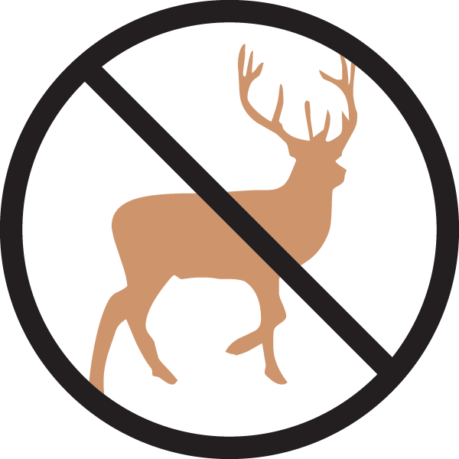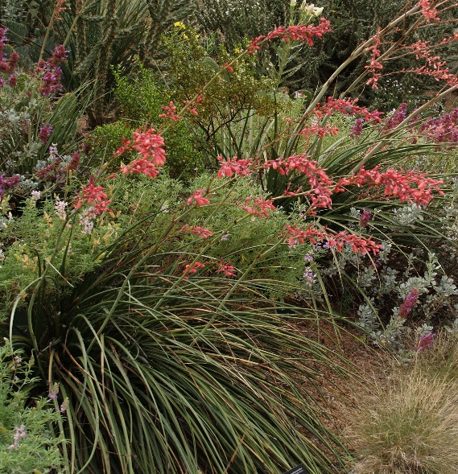

**Height: 3-4 ft. Width: 3-4 ft.**

This graceful native of Texas and Mexico has arching, evergreen grass-like leaves with captivating curly white filaments. Tall spikes of brilliant rose-pink, yellow-throated tubular blossoms curve skyward with elegance and are an instant magnet for humming-birds from early summer to autumn.

**Culture:** Loam or sandy soil

**Hardiness:** USDA zones 5-10



WIND. HAIL. SNOW. SUN

**BRING IT ON**

www.plantselect.org

