

**Seven-Son Flower**

*Heptacodium miconioides*

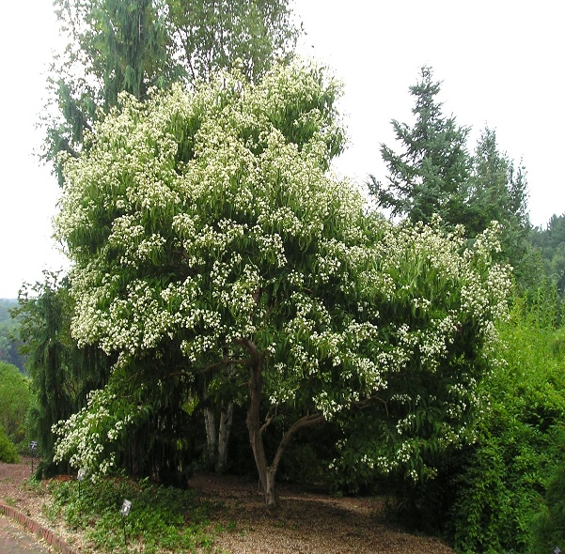

**Height: 18-25 ft. Width: 10-15 ft.**

Lush-looking large shrub or small tree that produces masses of fragrant white flowers in late summer and equally attractive persistent cherry-red sepals in fall. Fast growing with attractive, peeling bark. This unusual Chinese member of the honeysuckle family is very adaptable in a wide range of climates.

**Culture:** Loam or sandy loam

**Hardiness:** USDA zones 5-9



WIND. HAIL. SNOW. SUN

**BRING IT ON**

www.plantselect.org

