

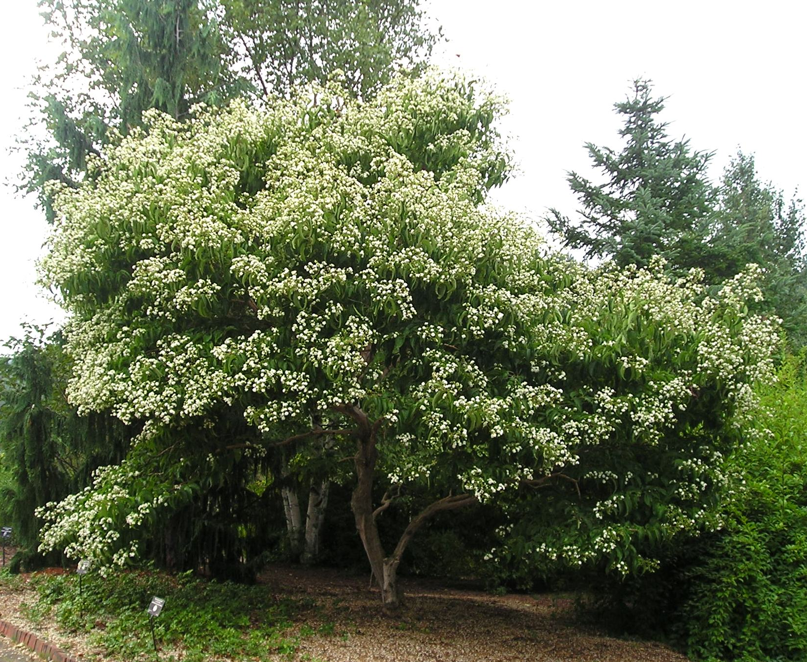
Height: 12-20’
Width: 8-15’
Blooms: August to September
Sun: Full sun to partial shade
Water: Moderate
Hardiness: USDA zones 4-9 (up to 7,000’)
Culture: Sandy or loamy soil
Recommended: 2008
Large Shrub or Small Tree
Lush-looking large shrub or small tree that produces masses of fragrant white flowers in late summer and equally attractive persistent cherry-red sepals in fall. Fast growing with attractive, peeling bark. This unusual Chinese member of the honeysuckle family is very adaptable in a wide range of climates.

Seven-Son Flower
Heptacodium miconoides
www.plantselect.org

