

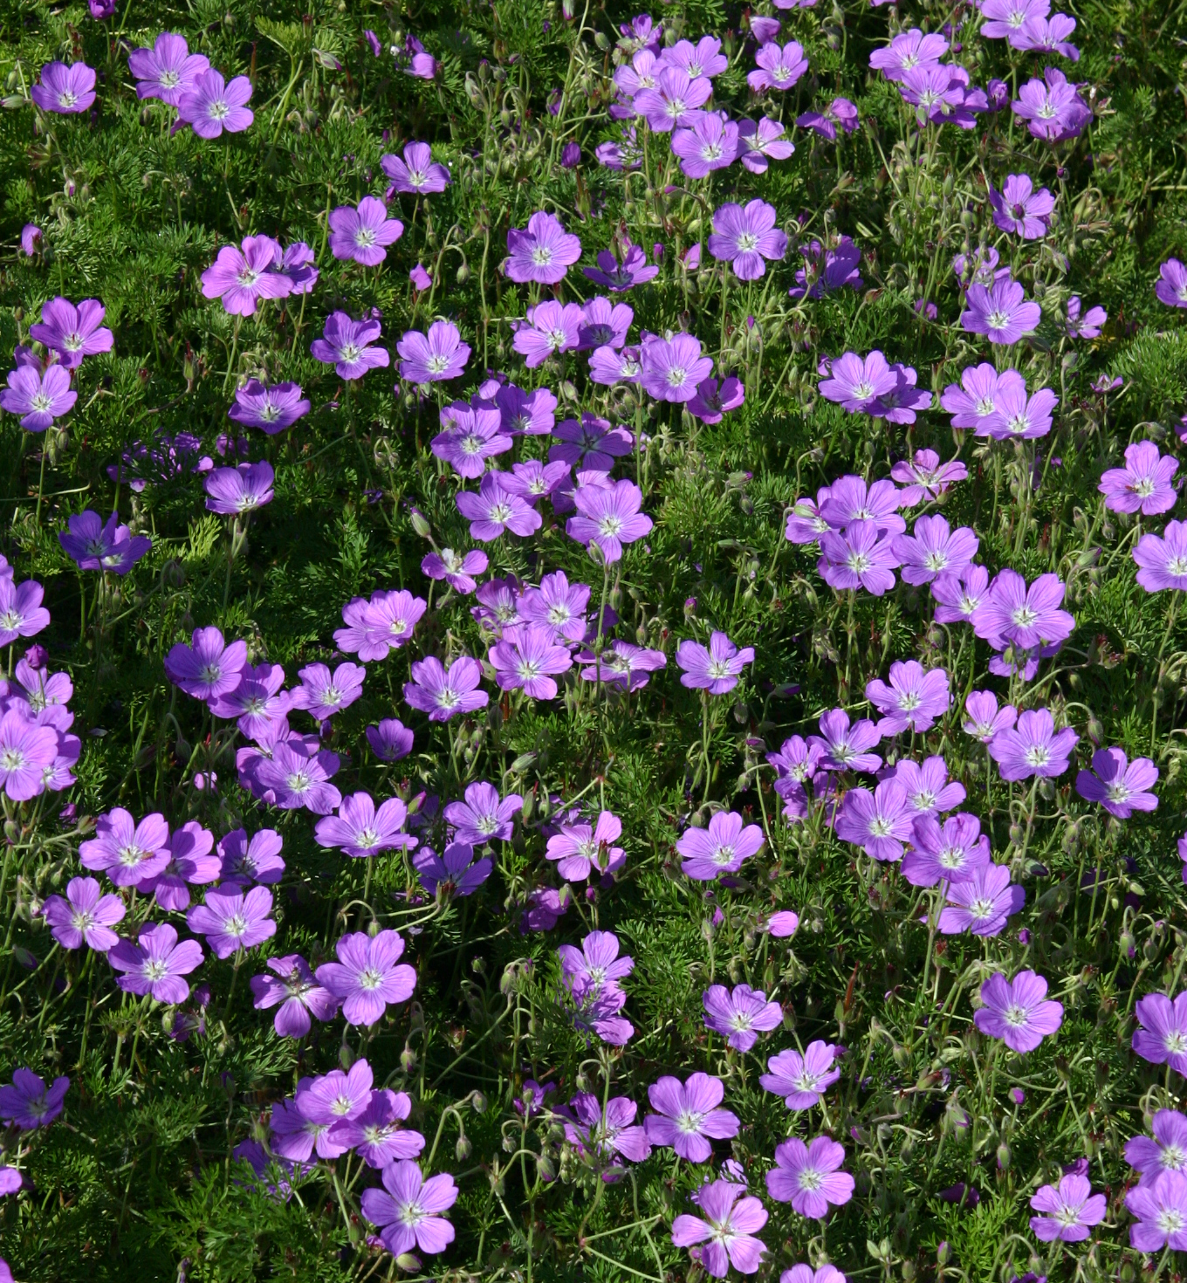
Height: 6-10”
Width: 20”
Blooms: Late spring to midsummer
Sun: Full sun to partial shade
Water: Moderate
Hardiness: USDA zones 4-8
Culture: Garden loam to gravelly soil
Introduced: 2003
Perennial
This alpine geranium from the Drakensberg Mountains of South Africa forms compact, evergreen mounds of foliage, resembling finely textured parsley, that take on hints of purple and scarlet in winter. The vivid purple flowers continue from spring into the summer. Adaptable and long-lived.

La Veta Lace® Geranium
Geranium magniflorum
www.plantselect.org

