

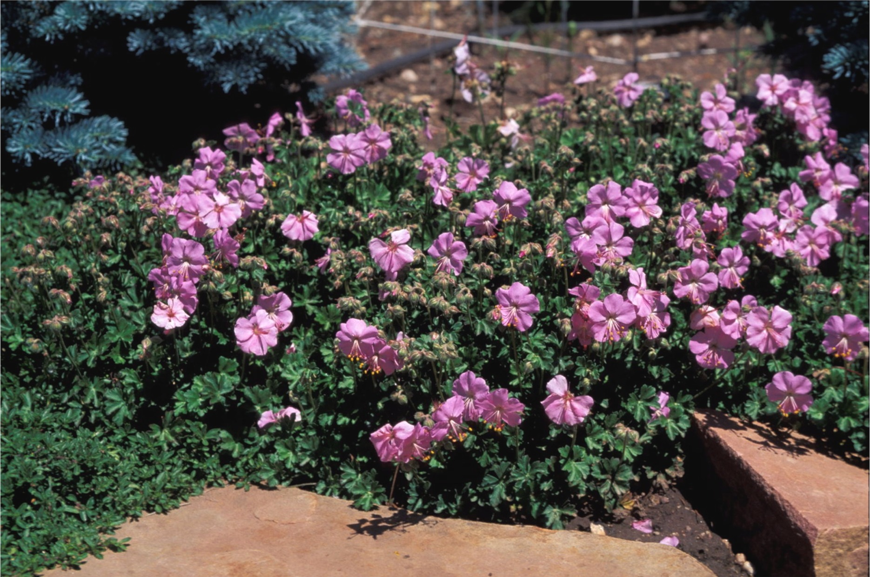
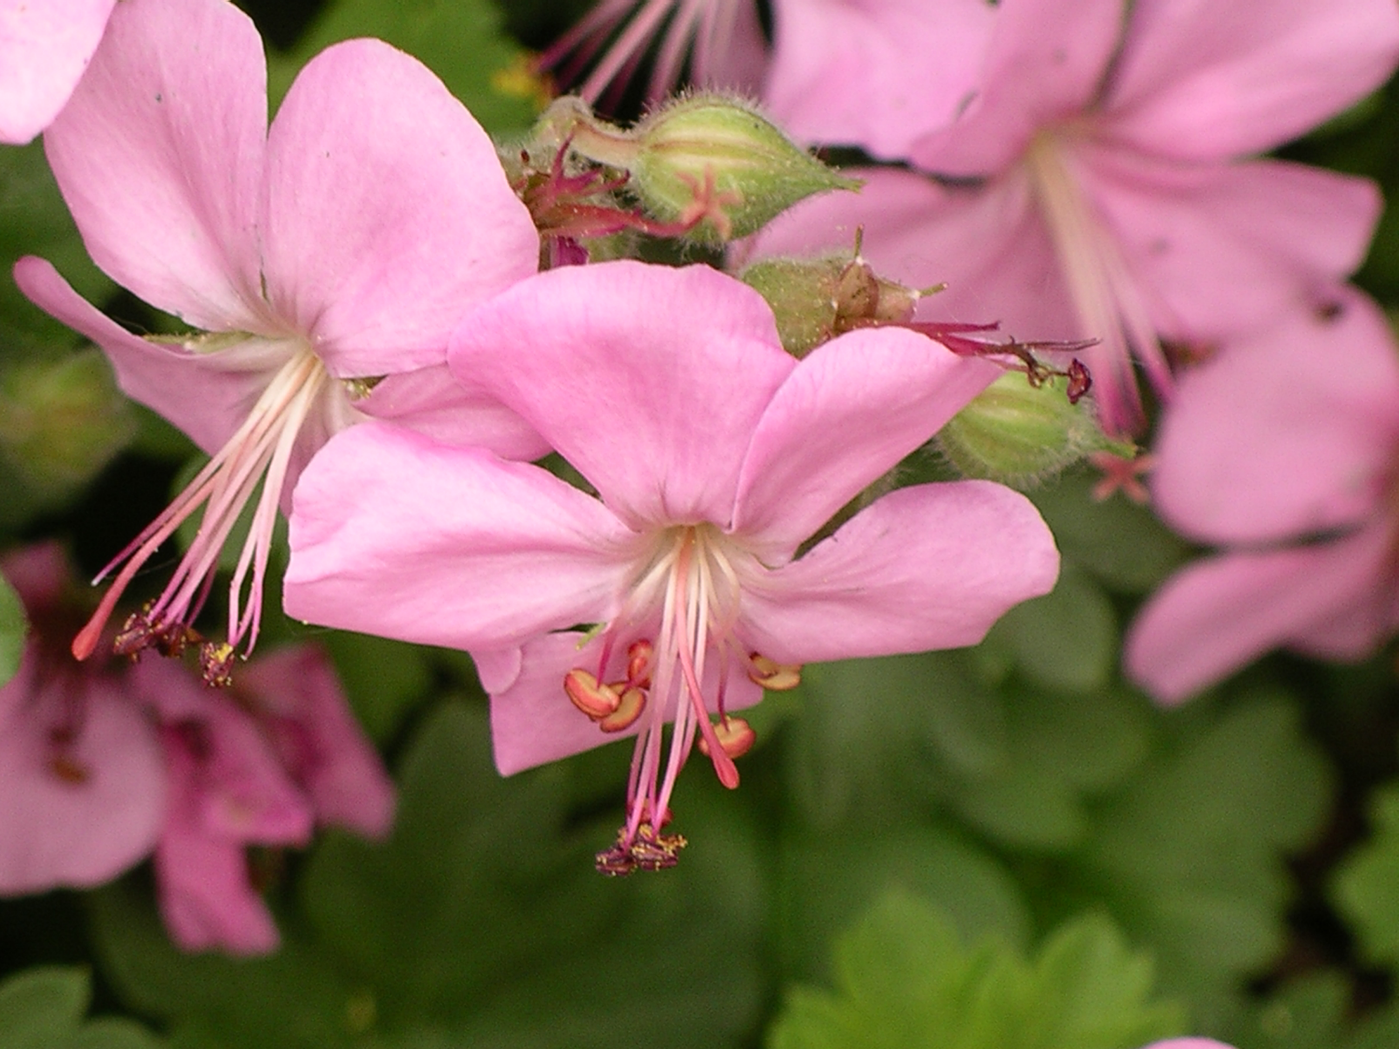


Height: 4-6”
Width: 10-15”
Blooms: Pink; late spring-early summer
Sun: Full sun to part shade
Water: Moderate to dry
Hardiness: USDA zones 5-7
Culture: Clay, loam, or sandy soils
Recommended: 2014
Perennial
Low-growing diminutive perennial geranium with clear pink flowers in late spring to early summer. Daintily cleft, aromatic leaves are glossy green all season long turning red in fall and on into early winter before drying and dropping. Excellent choice for small spaces, rock gardens and permanent containers.

Dalmatian Pink Cranesbill
Geranium dalmaticum
www.plantselect.org

