

**Colorado Gold® Gazania**

*Gazania linearis*

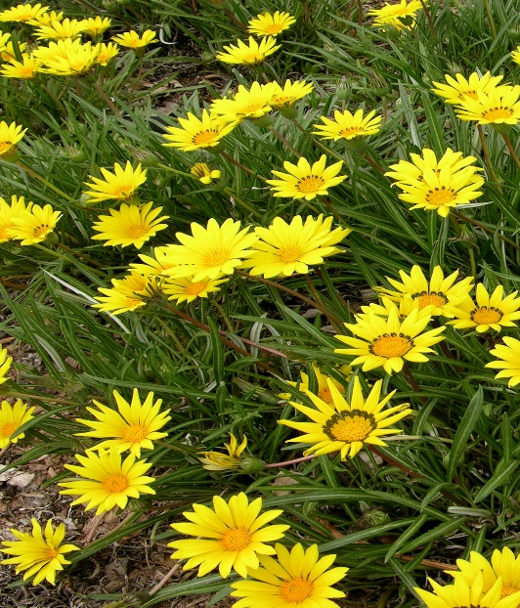

**Height: 4-6 in. Width: 10-12 in.**

This plant has glossy mounds of deep green, strap-shaped leaves with three-inch shiny yellow flowers throughout the season. This selection is cold hardy compared to the annual bedding gazanias.

**Culture:** Loam or sandy soil

**Hardiness:** USDA zones 4-8



WIND. HAIL. SNOW. SUN

**BRING IT ON**

www.plantselect.org

