

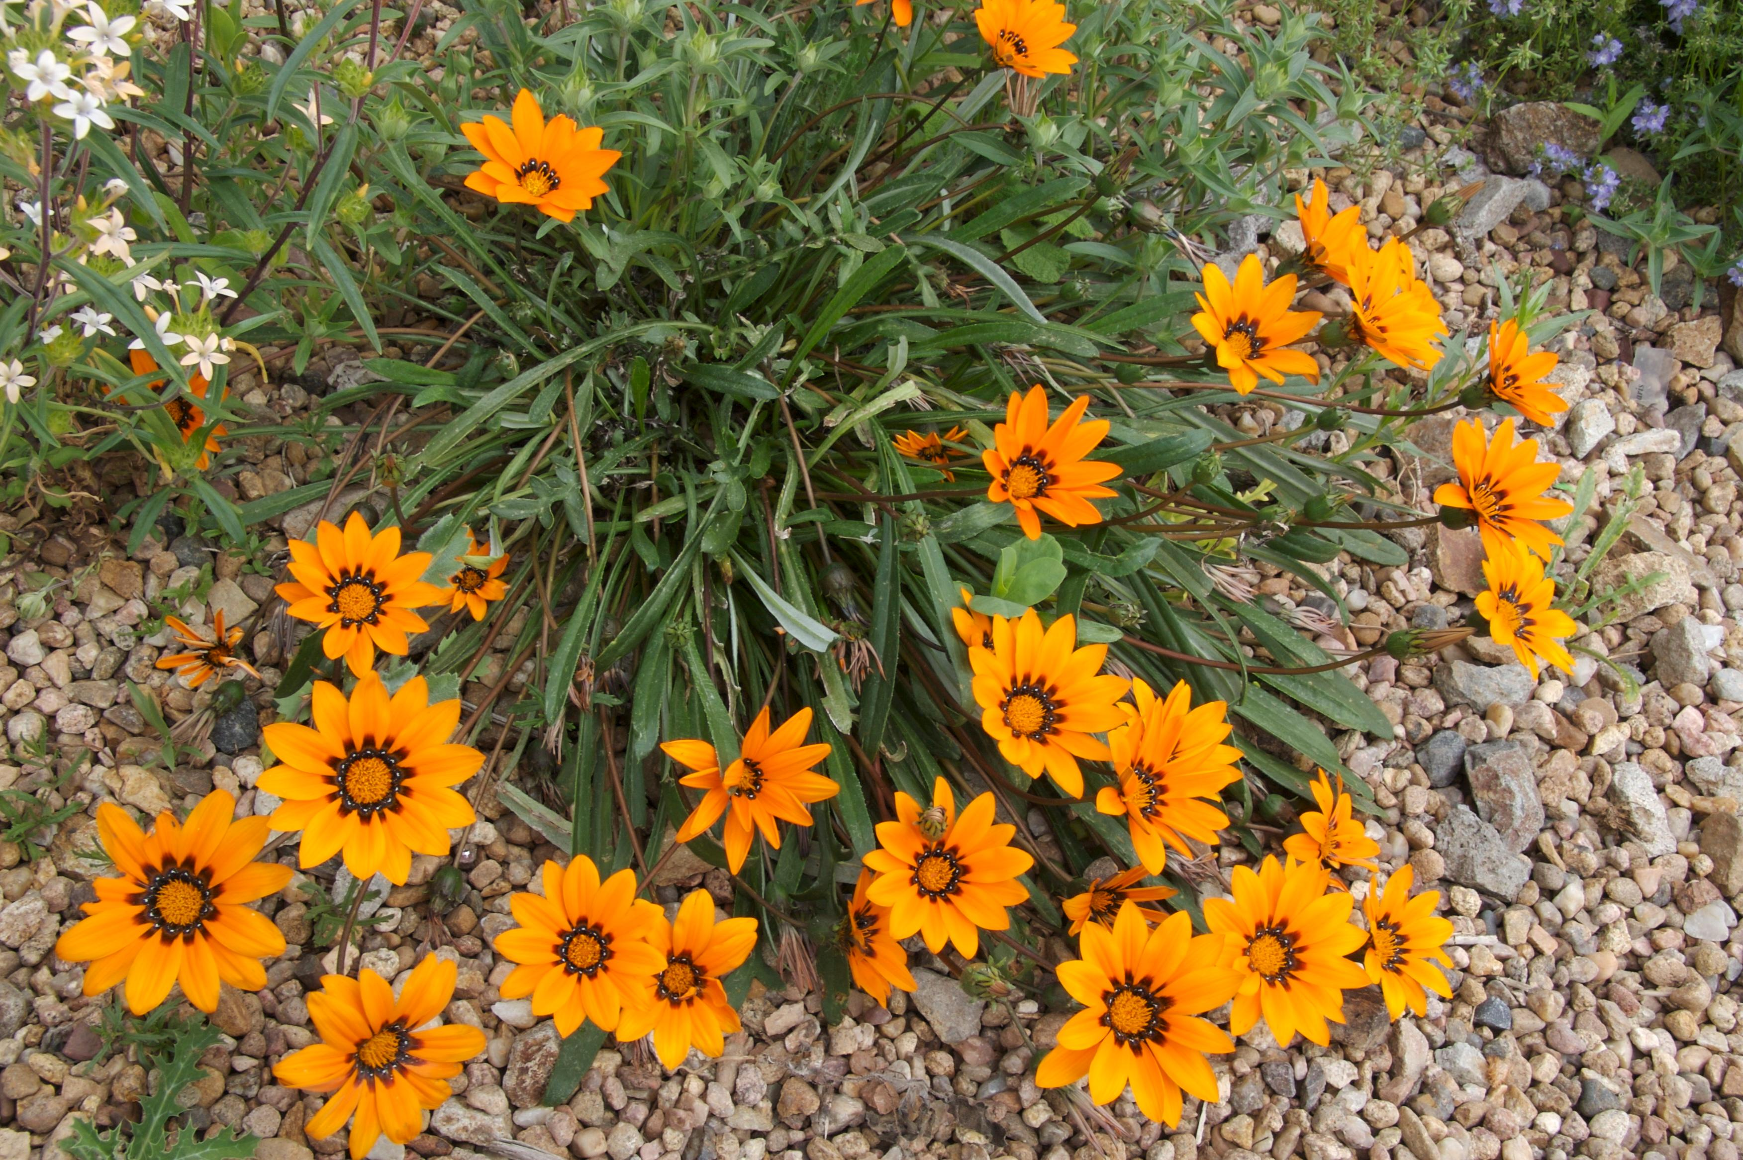
Height: 4”
Width: 10”
Blooms: Spring to fall
Sun: Full sun to partial shade
Water: Moderate to very dry
Hardiness: USDA zones 6-10
Culture: Average, clay, or sandy soil
Introduced: 2003
Perennial
Fluorescent orange daisies from earliest spring to late autumn create dazzling specimens ideal for mass displays. Glossy, dark green leaves develop a deep purple tinge in the winter months. Reseeds moderately in zone 5 and is hardy in protected microclimates.

Tanager® Gazania
Gazania krebsiana
www.plantselect.org

