
Tanager® Gazania
Gazania krebsiana

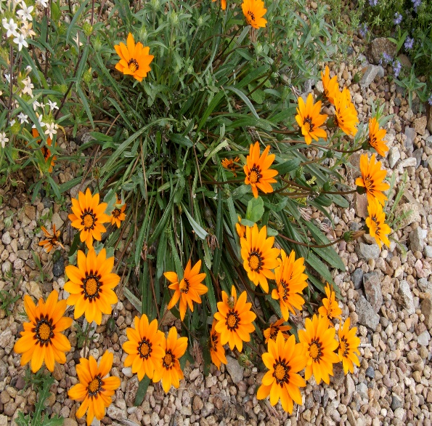






Height: 4-6 in. Width: 10-12 in.
Fluorescent orange daisies from earliest spring to late autumn create dazzling specimens ideal for mass displays. Glossy, dark green leaves develop a deep purple tinge in the winter months. Reseeds moderately in zone 5 and is hardy in protected microclimates.
Culture: Clay, loam or sandy soil
Hardiness: USDA zones 6-9



WIND. HAIL. SNOW. SUN
BRING IT ON

www.plantselect.org



