

**Tanager® Gazania**

*Gazania krebsiana*

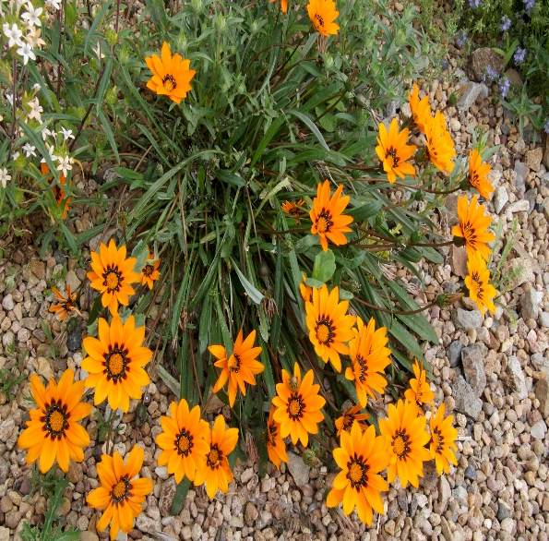

**Height: 4-6 in. Width: 10-12 in.**

Fluorescent orange daisies from earliest spring to late autumn create dazzling specimens ideal for mass displays. Glossy, dark green leaves develop a deep purple tinge in the winter months. Reseeds moderately in zone 5 and is hardy in protected microclimates.

**Culture:** Clay, loam or sandy soil

**Hardiness:** USDA zones 6-9



WIND. HAIL. SNOW. SUN

**BRING IT ON**

www.plantselect.org

