



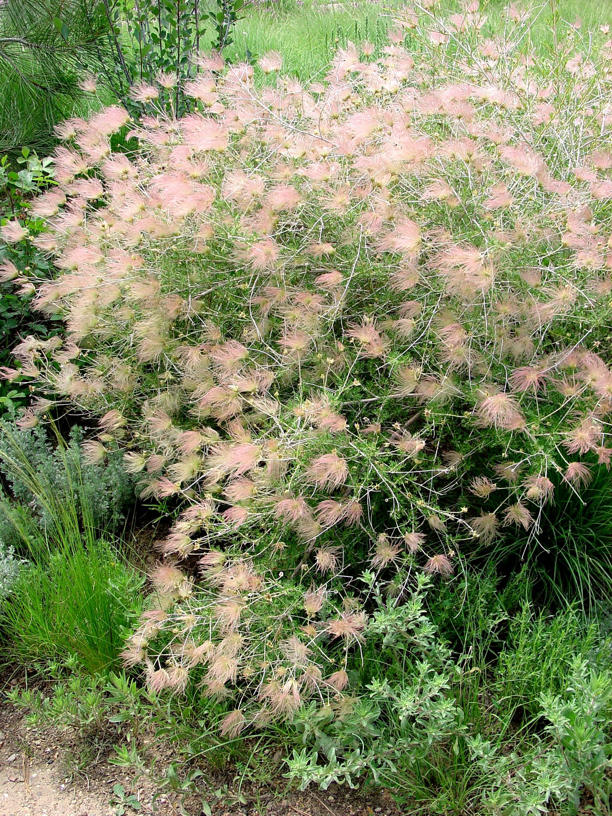
Height: 4-6’
Width: 4-6’
Blooms: May to September
Sun: Full sun to partial shade
Water: Moderate to dry
Hardiness: USDA zones 4-8
Culture: Sandy soil or clay loam
Introduced: 2002
Shrub
A glorious, native shrub of the Southwest with anemone-like, pale pink to white blossoms from spring to fall. Feathery, pink seed heads provide a dramatic second act throughout the winter.

Apache Plume
Fallugia paradoxa
www.plantselect.org

