
Apache Plume
Fallugia paradoxa






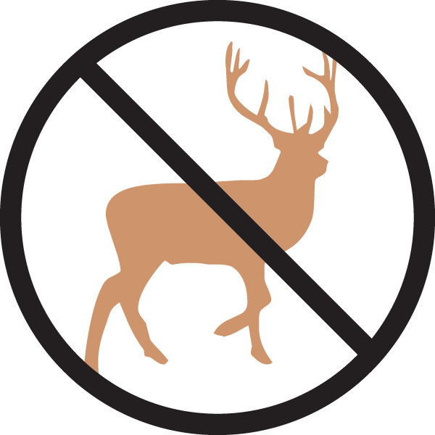

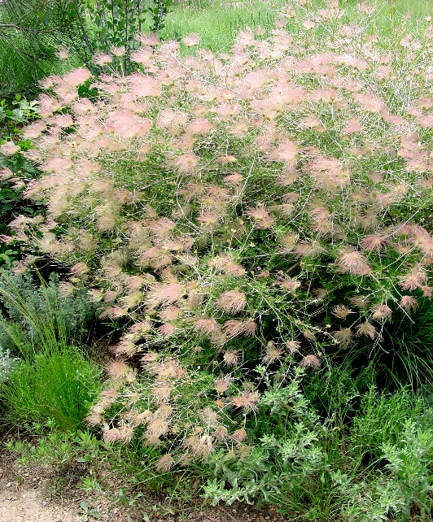

Height: 4-6 ft. Width: 4-6 ft.
A glorious, native shrub of the Southwest with anemone-like, pale pink to white blossoms from spring to fall. Feathery, pink seed heads provide a dramatic second act throughout the winter.
Culture: Clay, loam, or sandy soil
Hardiness: USDA zones 4-8



WIND. HAIL. SNOW. SUN
BRING IT ON

www.plantselect.org



