

**Apache Plume**

*Fallugia paradoxa*

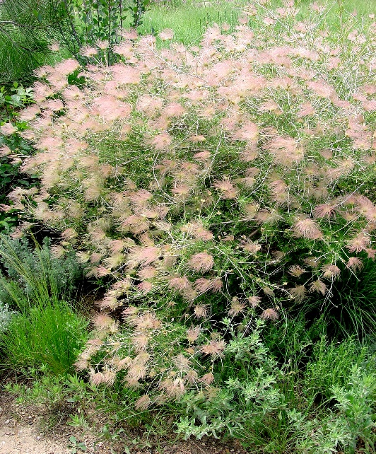

**Height: 4-6 ft. Width: 4-6 ft.**

A glorious, native shrub of the Southwest with anemone-like, pale pink to white blossoms from spring to fall. Feathery, pink seed heads provide a dramatic second act throughout the winter.

**Culture:** Clay, loam, or sandy soil

**Hardiness:** USDA zones 4-8



WIND. HAIL. SNOW. SUN

**BRING IT ON**

www.plantselect.org

