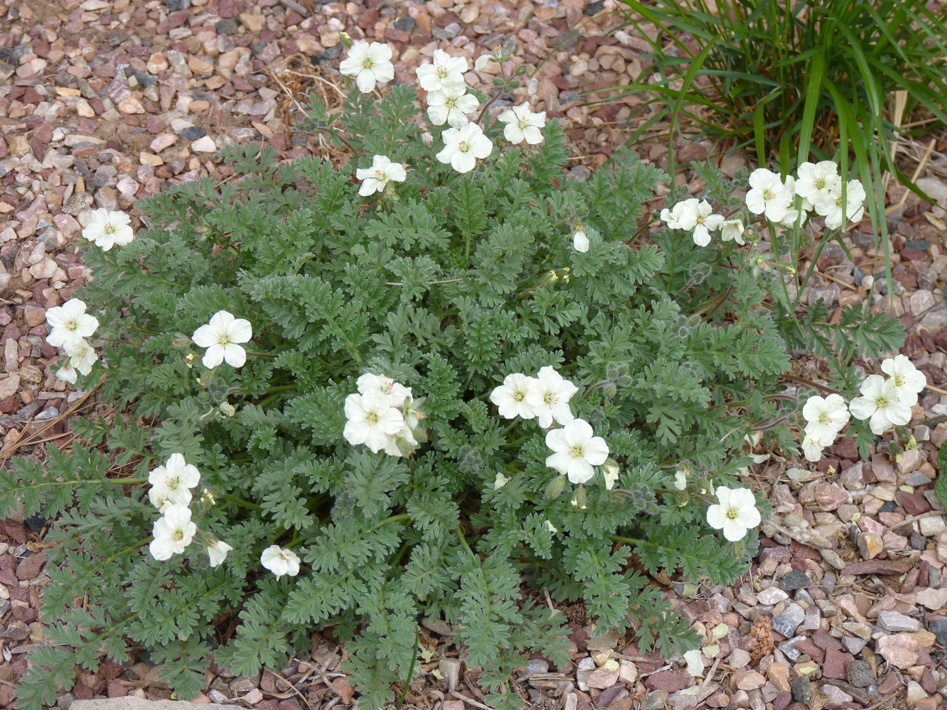



Height: 8-10”
Width: 10-25”
Blooms: April to late summer
Sun: Full sun to partial shade
Water: Moderate to xeric
Hardiness: USDA zones 4-9 (up to 8,000’)
Culture: Loam, sandy, or gravelly soils
Introduced: 2011
Perennial
Silvery mounds of evergreen, ferny foliage decorative in their own right. Fragrant, soft yellow, geranium-like flowers from early spring until late summer. Long lived, easy, and adaptable.

Golden Storksbill
Erodium chrysanthum
www.plantselect.org

