


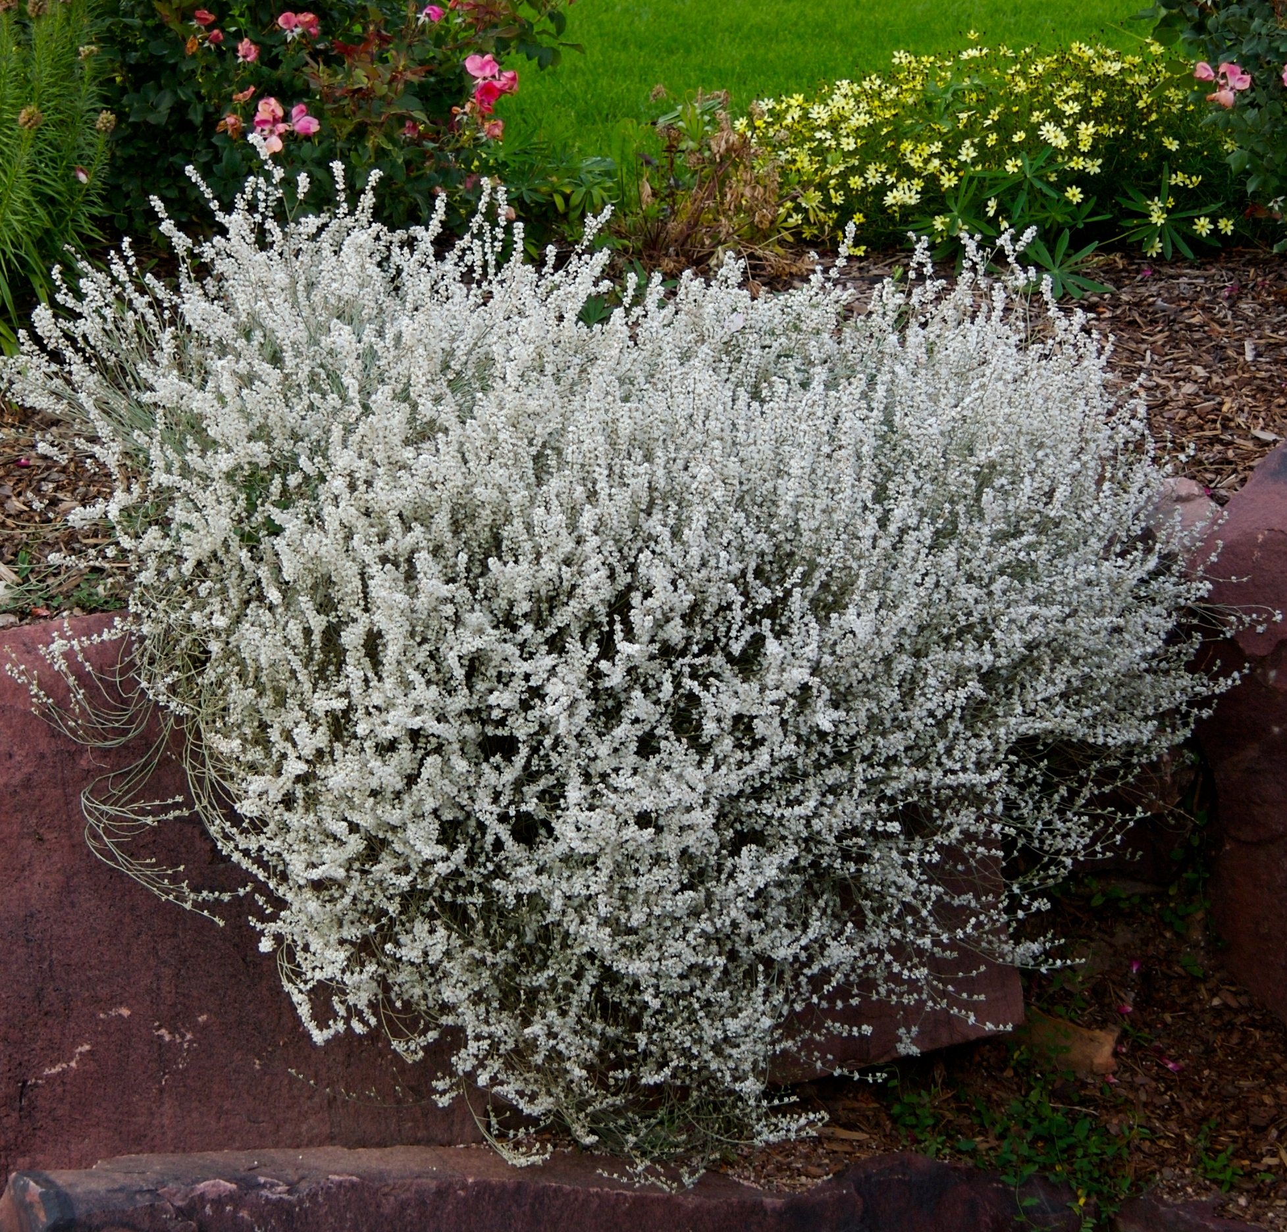
Height: 18-20”
Width: 18-24”
Blooms: August to November
Sun: Full sun
Water: Dry; xeric
Hardiness: USDA zones 4-9 (up to 8,000’)
Culture: Lean and dry
Introduced: 2010
Perennial
Billowy domes of glistening white flowers gradually turn a ruddy fawn color over a period of months in late summer and fall. This long-lived gorgeous wildflower from the Chihuahuan grasslands of the Southwest will light up your xeriscape. A perfect complement for rabbitbrush, Russian sage and SUNSET® hyssop.

Snow Mesa Buckwheat
Eriogonum wrightii var. wrightii
www.plantselect.org

