
Snow Mesa Buckwheat
Eriogonum wrightii var. wrightii




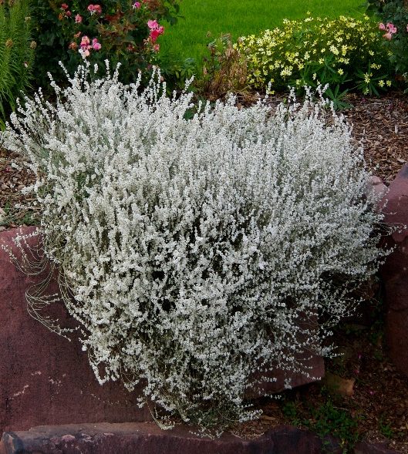



Height: 18-20 in. Width: 18-24 in.
Billowy domes of glistening white flowers gradually turn a ruddy fawn color over a period of months in late summer and fall. This long-lived gorgeous wildflower from the Chihuahuan grasslands of the Southwest will light up your xeriscape
Culture: Sandy, well-drained soil
Hardiness: USDA zones 4-9



WIND. HAIL. SNOW. SUN
BRING IT ON

www.plantselect.org



