

**Snow Mesa Buckwheat**

*Eriogonum wrightii* var. *wrightii*

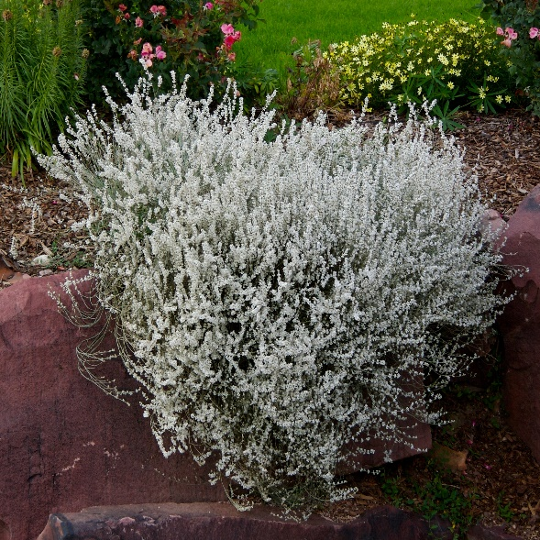

**Height: 18-20 in. Width: 18-24 in.**

Billowy domes of glistening white flowers gradually turn a ruddy fawn color over a period of months in late summer and fall. This long-lived gorgeous wildflower from the Chihuahuan grasslands of the Southwest will light up your xeriscape

**Culture:** Sandy, well-drained soil

**Hardiness:** USDA zones 4-9



WIND. HAIL. SNOW. SUN

**BRING IT ON**

www.plantselect.org

