
Kannah Creek® Buckwheat
Eriogonum umbellatum var. aureum ‘Psdowns’







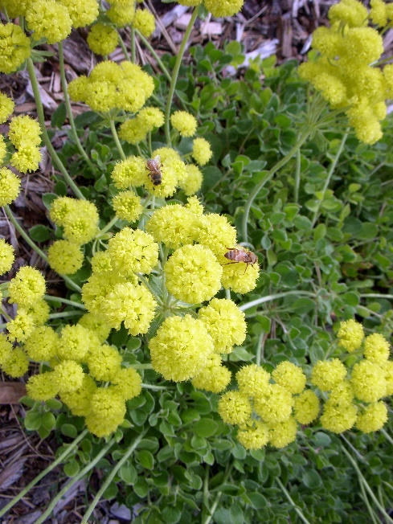

Height: 10-14 in. Width: 18-24 in.
Masses of yellow flowers in May turn orange in summer as they age. Spreading green foliage changes to a vivid purple-red in winter. Vigorous and adaptable western native.
Culture: Clay, loam, or sandy soil
Hardiness: USDA zones 3-8



WIND. HAIL. SNOW. SUN
BRING IT ON

www.plantselect.org



