

**Kannah Creek® Buckwheat**

*Eriogonum umbellatum* var. *aureum* ‘Psdowns’

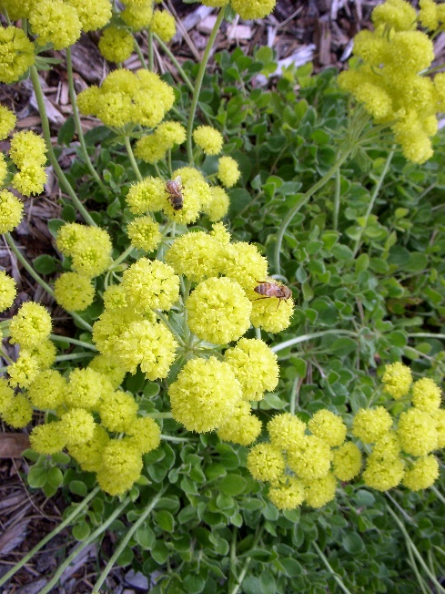

**Height: 10-14 in. Width: 18-24 in.**

Masses of yellow flowers in May turn orange in summer as they age. Spreading green foliage changes to a vivid purple-red in winter. Vigorous and adaptable western native.

**Culture:** Clay, loam, or sandy soil

**Hardiness:** USDA zones 3-8



WIND. HAIL. SNOW. SUN

**BRING IT ON**

www.plantselect.org

