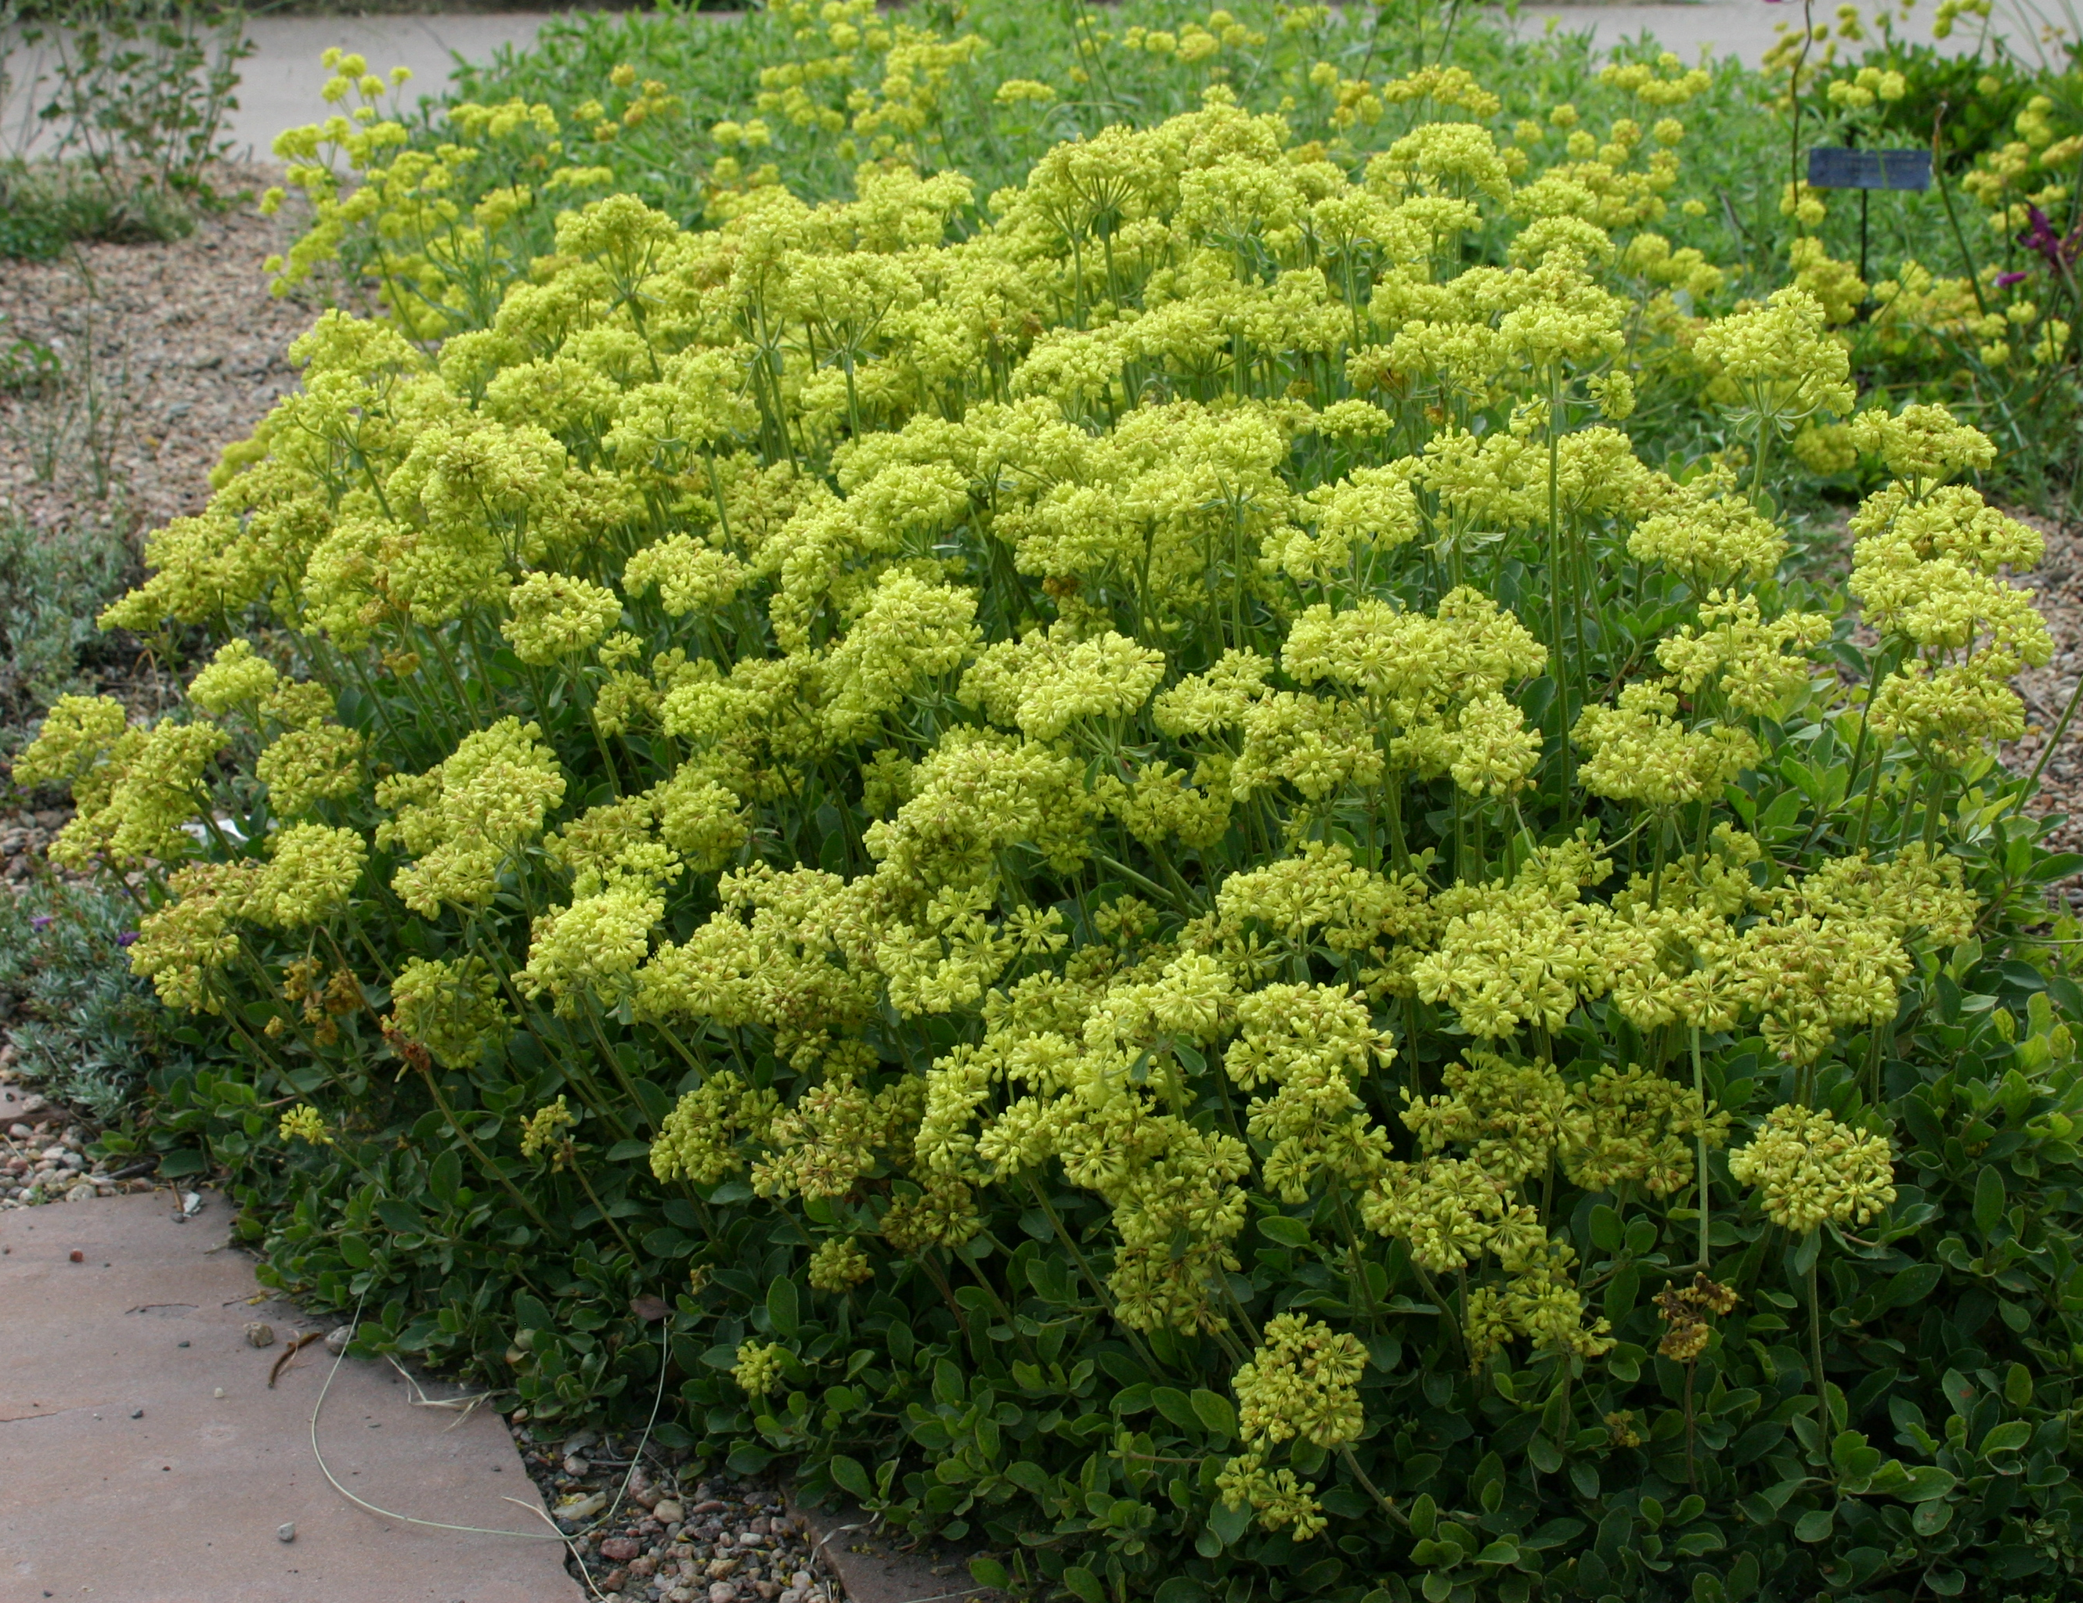



Height: 12-15”
Width: 12-24”
Blooms: May to July
Sun: Full sun to partial shade
Water: Moderate to xeric
Hardiness: USDA zones 3-8 (up to 10,000’)
Culture: Clay, loam or sandy soil
Introduced: 2007
Perennial
Masses of yellow flowers turn orange as they age. Spreading green foliage changes to a vivid purple-red in winter. Vigorous and adaptable western native.

Kannah Creek® Buckwheat
Eriogonum umbellatum var. aureum ‘Psdowns’
www.plantselect.org

