
Alpine Willowherb
Epilobium fleischeri

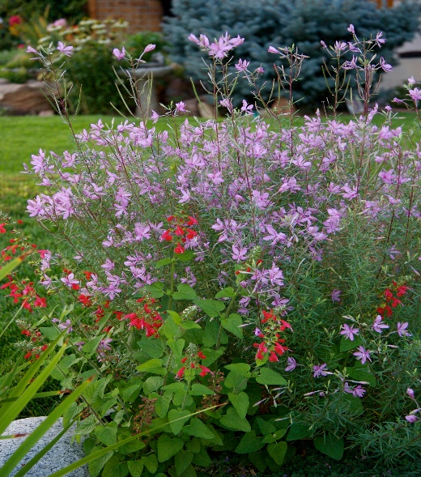





Height: 16-20 in. Width: 8-12 in.
This compact willowherb from the Alps is underused in the garden. Blooms spring to fall with delicate pink flowers, borne on reddish stems against gray-green foliage. Attractive silvery seed heads add continuing interest.
Culture: Loam or sandy loam
Hardiness: USDA zones 3-8



WIND. HAIL. SNOW. SUN
BRING IT ON

www.plantselect.org



