

**Alpine Willowherb**

*Epilobium fleischeri*

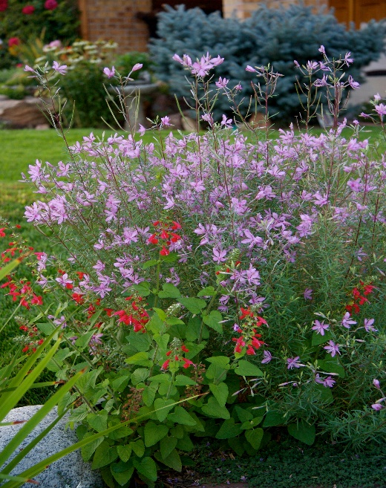

**Height: 16-20 in. Width: 8-12 in.**

This compact willowherb from the Alps is underused in the garden. Blooms spring to fall with delicate pink flowers, borne on reddish stems against gray-green foliage. Attractive silvery seed heads add continuing interest.

**Culture:** Loam or sandy loam

**Hardiness:** USDA zones 3-8



WIND. HAIL. SNOW. SUN

**BRING IT ON**

www.plantselect.org

