

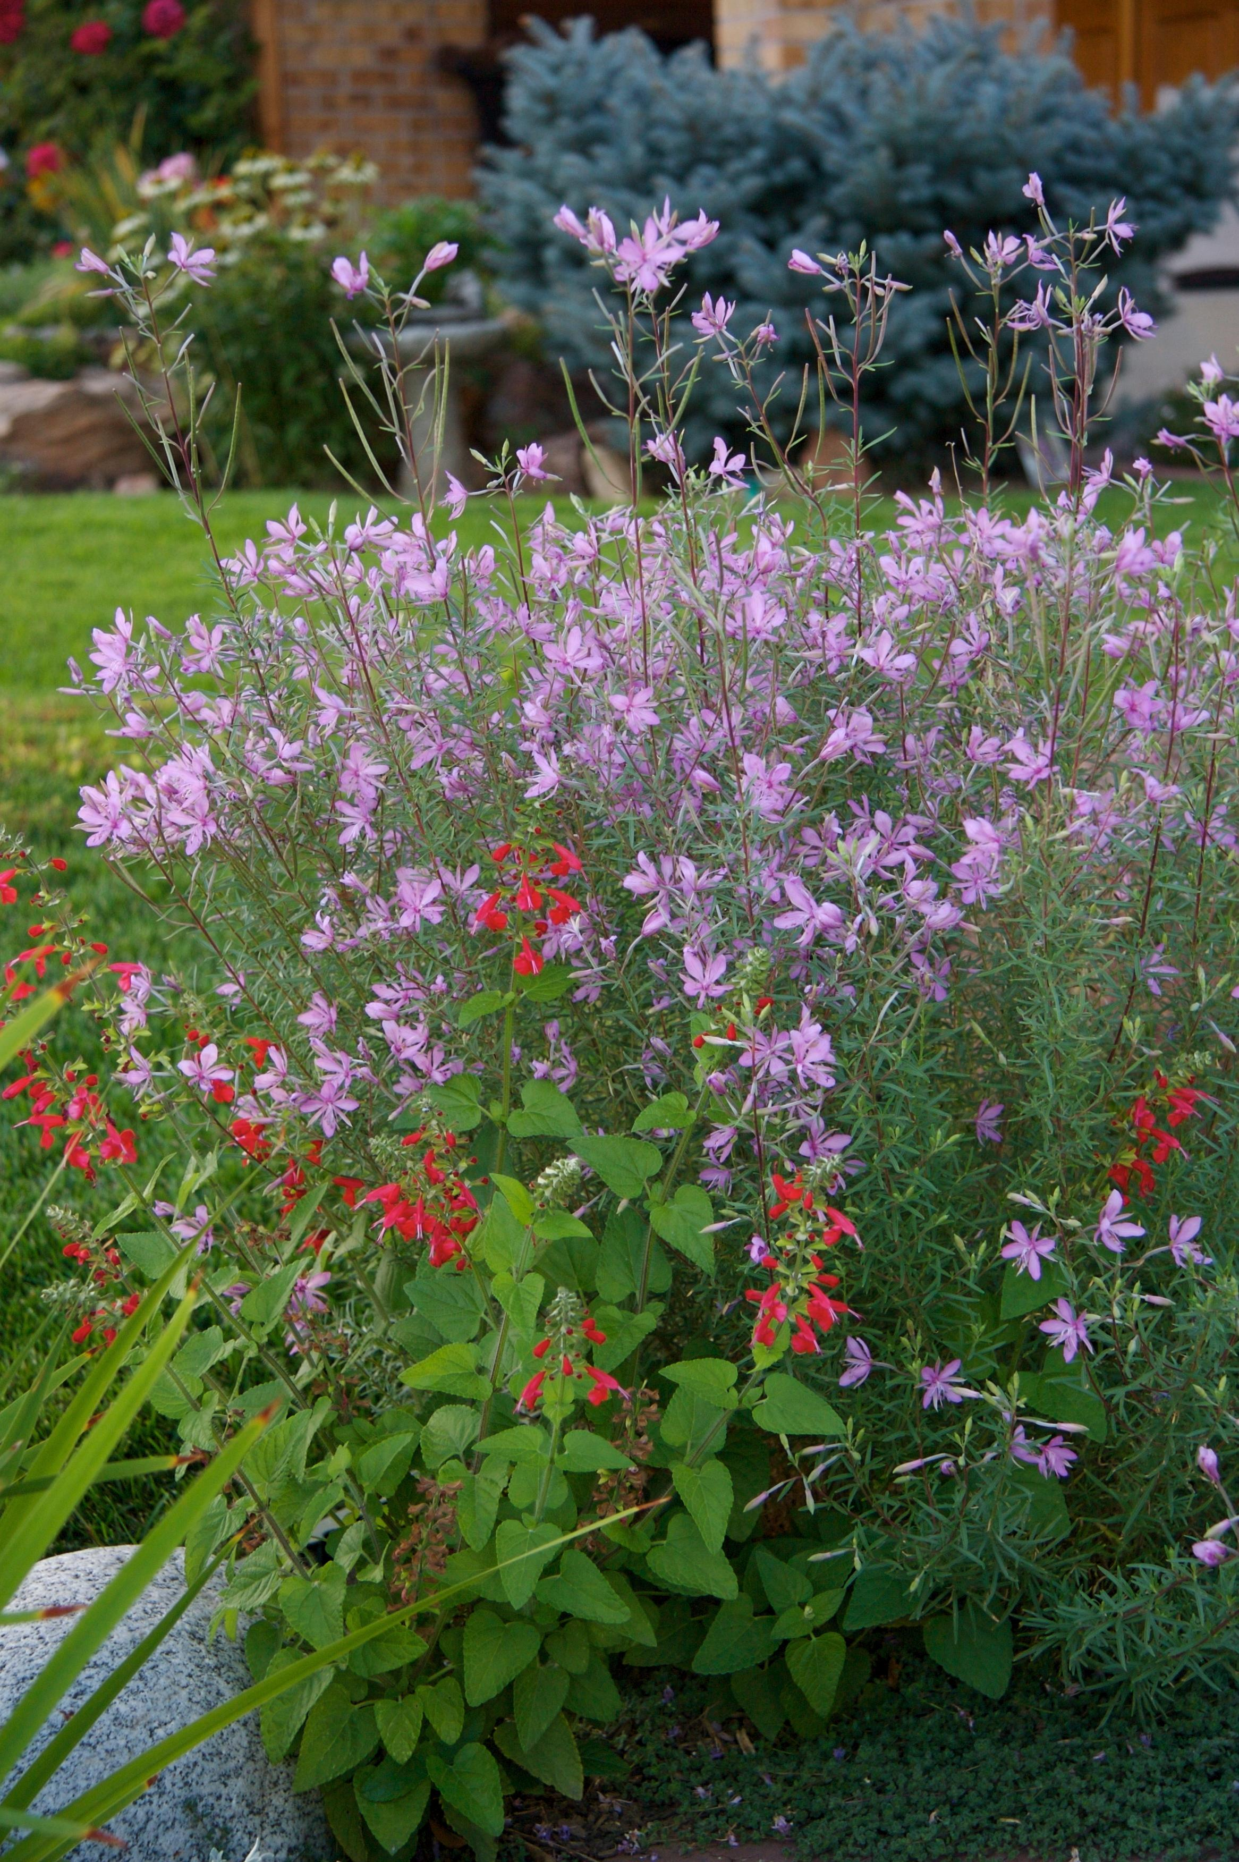
Height: 18”
Width: 10”
Blooms: Spring to fall
Sun: Full sun to partial shade
Water: Moderate
Hardiness: USDA zones 3-8
Culture: Garden loam or sandy soil
Introduced: 2002
Perennial
This compact willowherb from the Alps is underused in the garden. Its delicate pink flowers, borne on reddish stems against gray-green foliage, are a welcome addition to any garden. Attractive silvery seed heads add continuing interest.

Alpine Willowherb
Epilobium fleischeri
www.plantselect.org

