
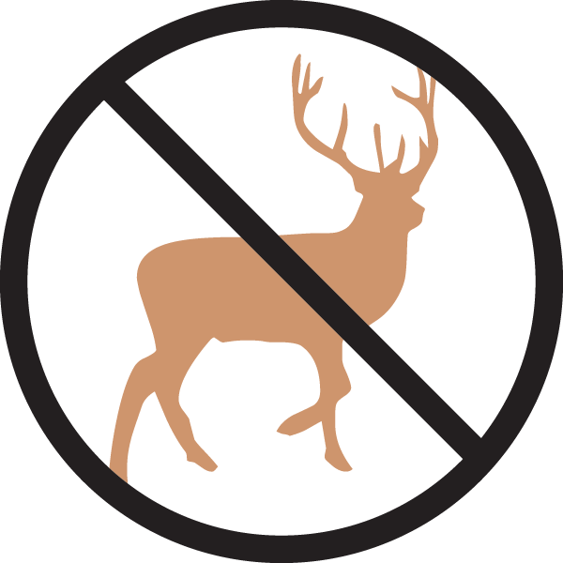

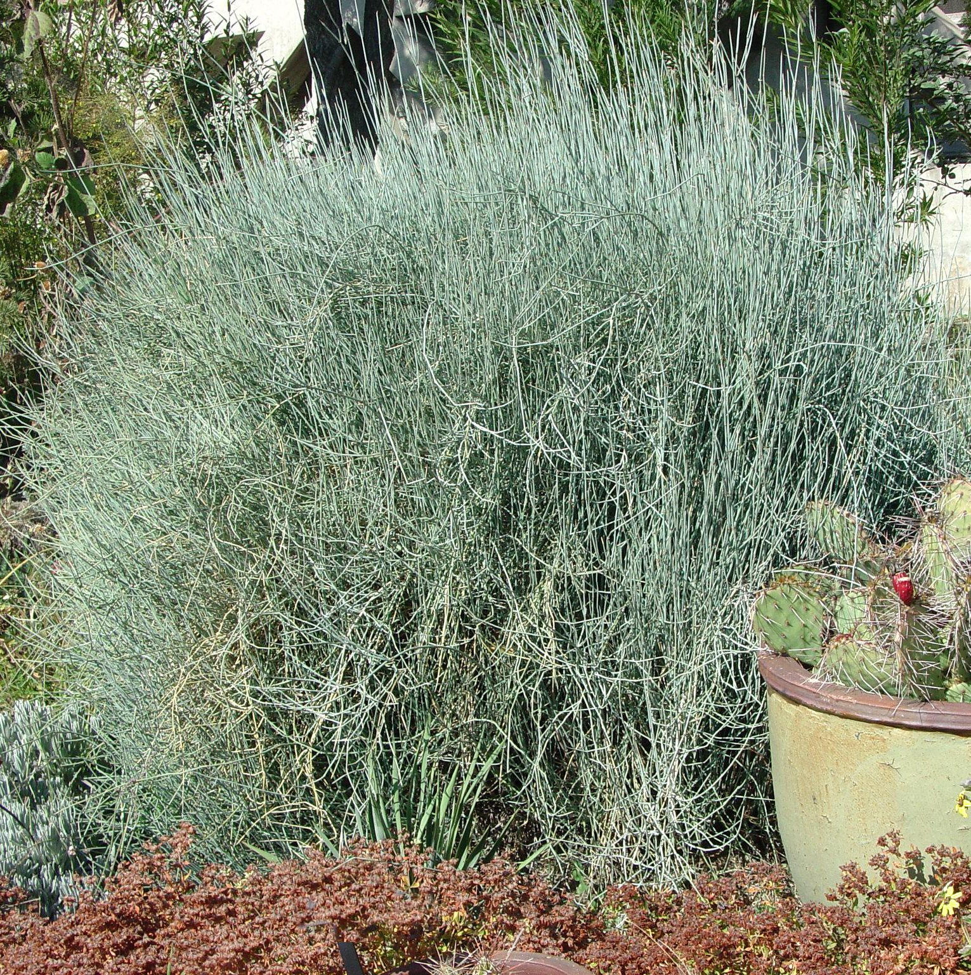
Height: 4-6’
Width: 3-8’
Blooms: Spring
Sun: Full sun to partial shade
Water: Moderate to xeric
Hardiness: USDA zones 4b-9
Culture: Average, clay, or sandy soil
Introduced: 2004
Shrub
Finely textured blue-green stems with a conspicuous froth of yellow blooms often followed by berries. Related to conifers. Bluestem Joint Fir is extremely heat and drought tolerant. Dense branching provides excellent winter interest.

Bluestem Joint Fir
Ephedra equisetina
www.plantselect.org

