
Bluestem Joint Fir
Ephedra equisetina

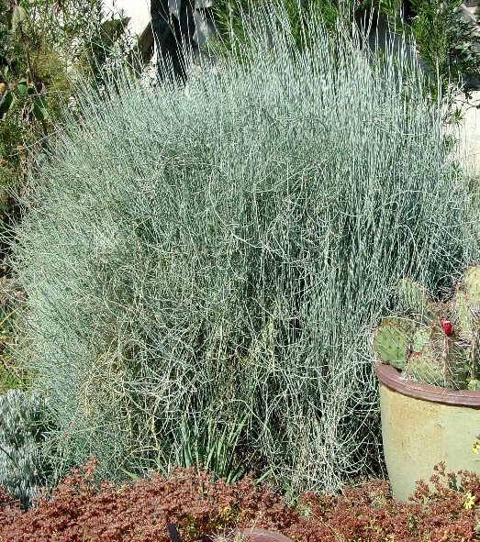


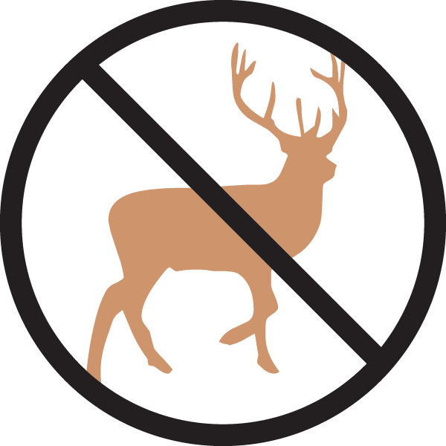





Height: 4-5 ft. Width: 6-8 ft.
Finely textured blue-green stems with a conspicuous froth of yellow blooms often followed by berries. Related to conifers. Bluestem Joint Fir is extremely heat and drought tolerant. Dense branching provides excellent winter interest.
Culture: Clay, loam, or sandy soil
Hardiness: USDA zones 4b-9



WIND. HAIL. SNOW. SUN
BRING IT ON

www.plantselect.org



