

**Bluestem Joint Fir**

*Ephedra equisetina*

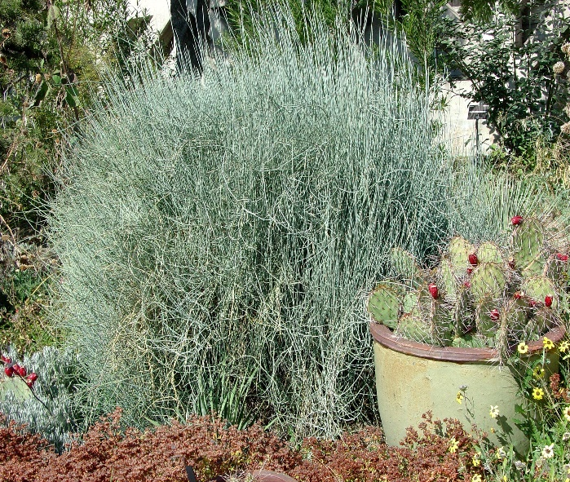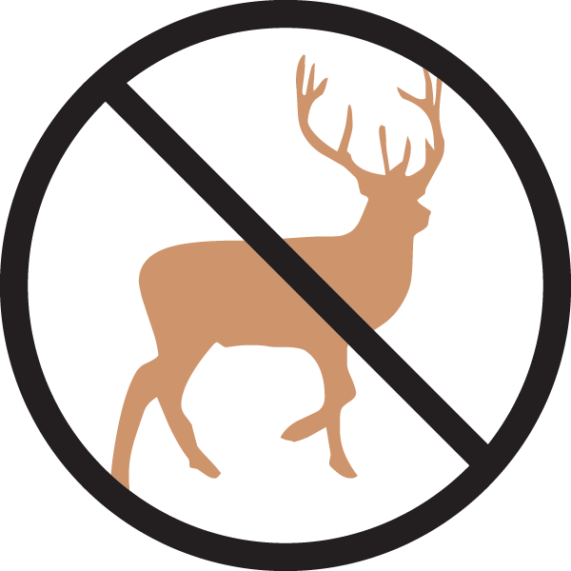

**Height: 4-5 ft. Width: 6-8 ft.**

Finely textured blue-green stems with a conspicuous froth of yellow blooms often followed by berries. Related to conifers. Bluestem Joint Fir is extremely heat and drought tolerant. Dense branching provides excellent winter interest.

**Culture:** Clay, loam, or sandy soil

**Hardiness:** USDA zones 4b-9



WIND. HAIL. SNOW. SUN

**BRING IT ON**

www.plantselect.org

