



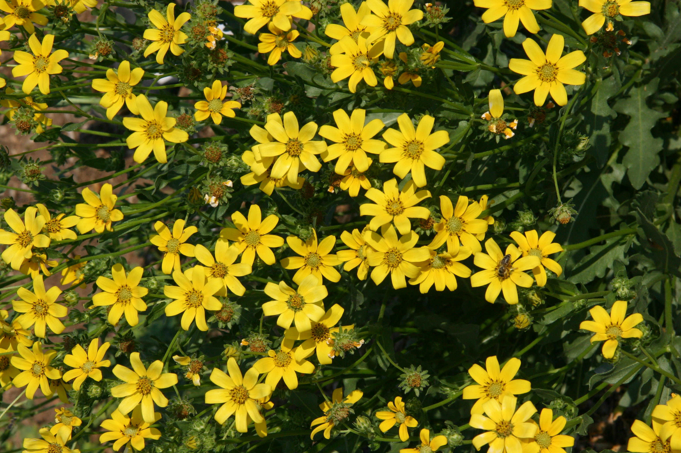
Height: 28”
Width: 14”
Blooms: May to frost
Sun: Part shade to full sun
Water: Moderate to dry
Hardiness: USDA zones 5-10
Culture: Clay, loam or sand
Recommended: 2015
Perennial
This “industrial strength” wildflower of the Southern Great Plains is incredibly tough and adaptable. Adorned nearly all summer with bright yellow daisies, this plant forms decorative rosettes of crisp, ruffled gray foliage. Resistant to deer and attractive to pollinators, this perennial is versatile and easy to grow.

Engelmann’s Daisy
Engelmannia peristenia
www.plantselect.org

