



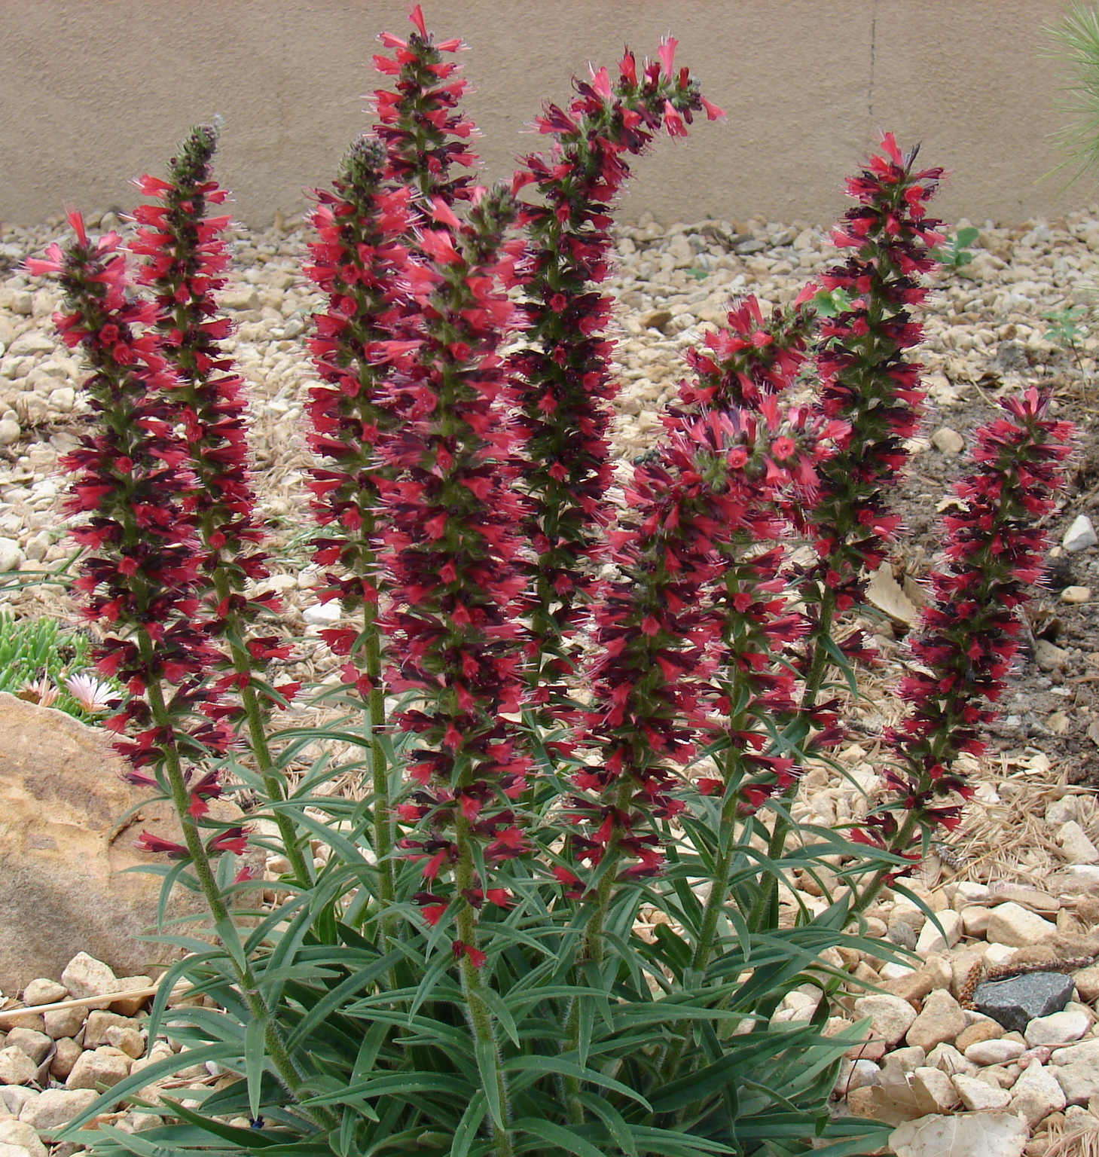
Height: 10-16”
Width: 6-8”
Blooms: May to frost (if deadheaded)
Sun: Full sun to partial shade
Water: Moderate to xeric
Hardiness: USDA zones 3-9 (up to 9,000’)
Culture: Clay, sandy, or loam soils
Introduced: 2010
Perennial
This astonishing perennial recently introduced from the Caucasus consists of a basal tuft of dark green, linear leaves which produce spikes of feathery, russet-red flowers in spring, re-blooming again in summer and fall if deadheaded. This adaptable plant resembles a reddish, spring-blooming liatris with vibrant designer color.

Red Feathers
Echium russicum (compact form)
www.plantselect.org

