


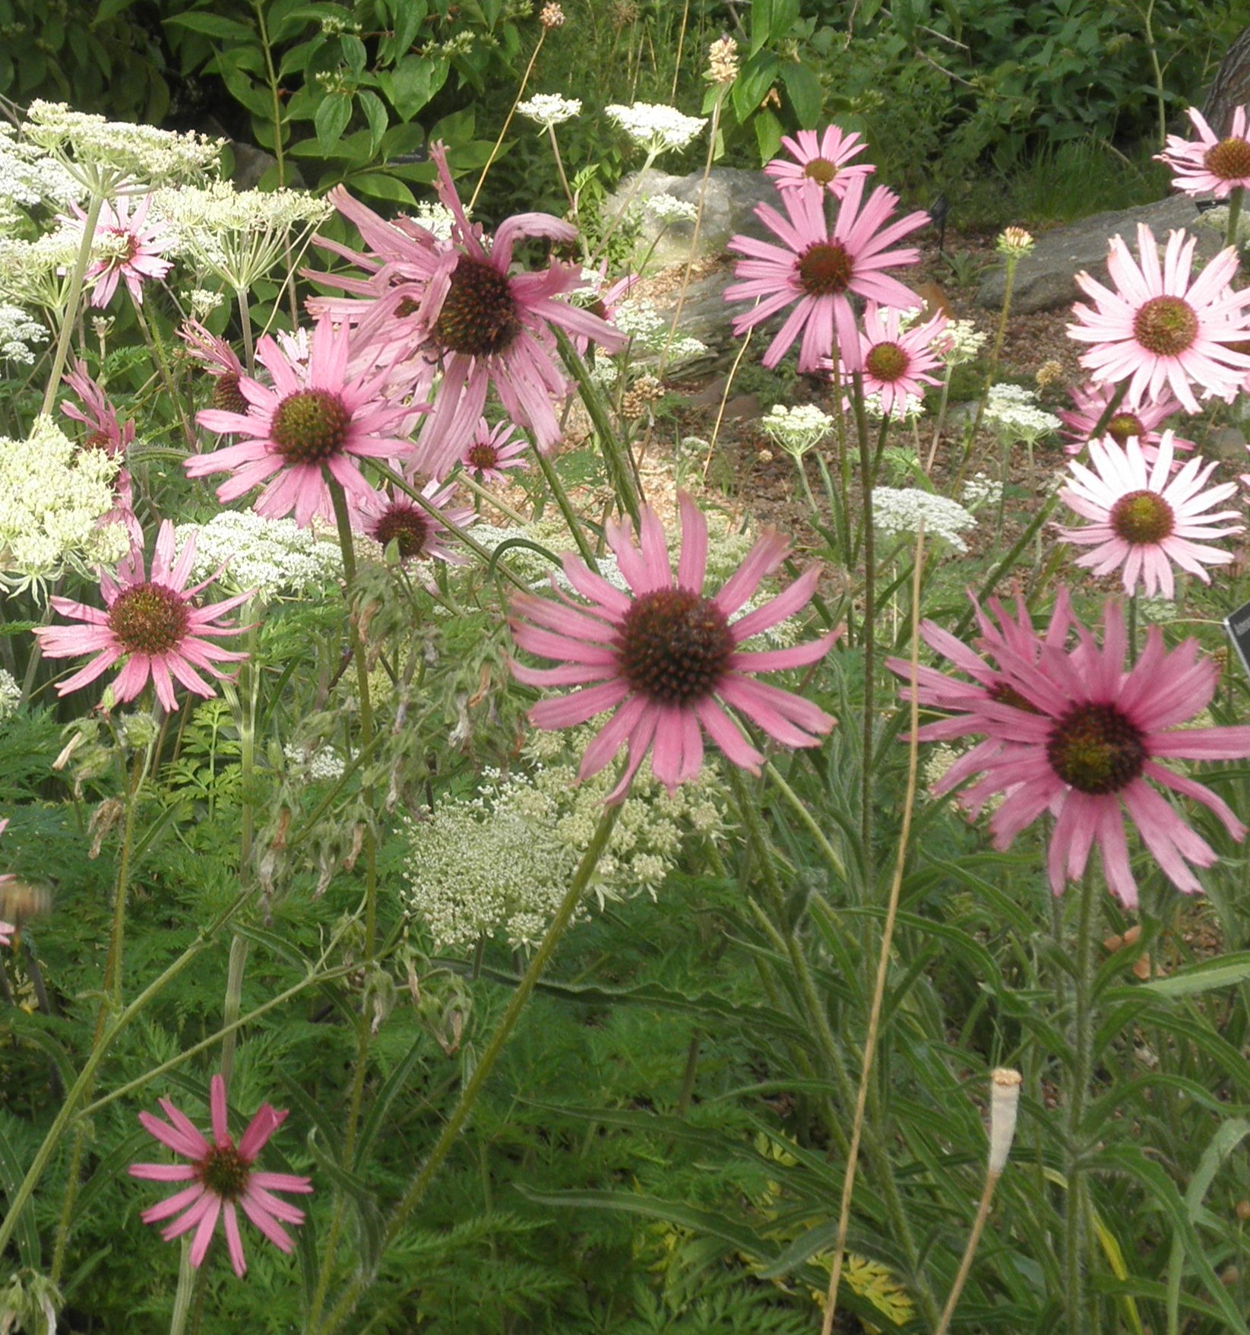
Height: 18-24”
Width: 15-18”
Blooms: June to August
Sun: Full sun to partial shade
Water: Moderate to dry
Hardiness: USDA zones 5-6
Culture: Sandy, clay, or loam soil
Introduced: 2013
Perennial
The American purple coneflower is a refreshing addition to summer borders with amazing adaptability to western gardens. Beautiful purple-pink flowers bloom cheerily during summer, always facing east so be sure to site properly.

Tennessee Purple Coneflower
Echinacea tennesseensis
www.plantselect.org

