

**Indigo Blue Dragonhead**

*Dracocephalum ruyschiana*

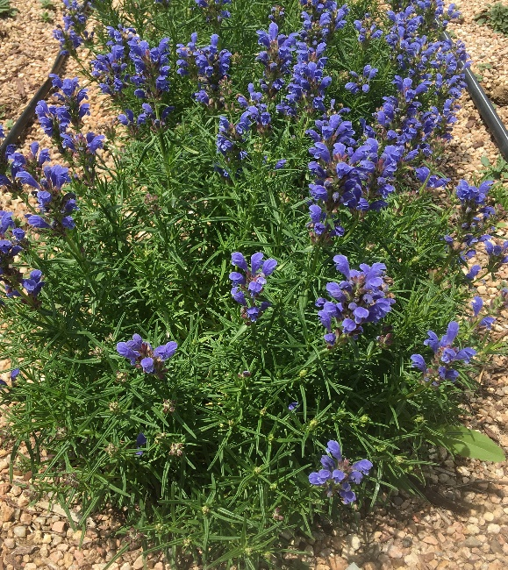

**Height: 14-16 in. Width: 10-12 in.**

An easy to grow tidy mounding plant with speckled dark blue flowers that bloom in early summer. This perennial will thrive in a dry meadow or rock garden setting and is tolerant of a wide range of soil types.

**Culture:** Low water to xeric- adaptable soils

**Hardiness:** USDA zones 3-8



WIND. HAIL. SNOW. SUN

**BRING IT ON**

www.plantselect.org

