

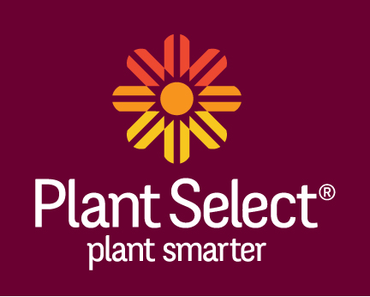
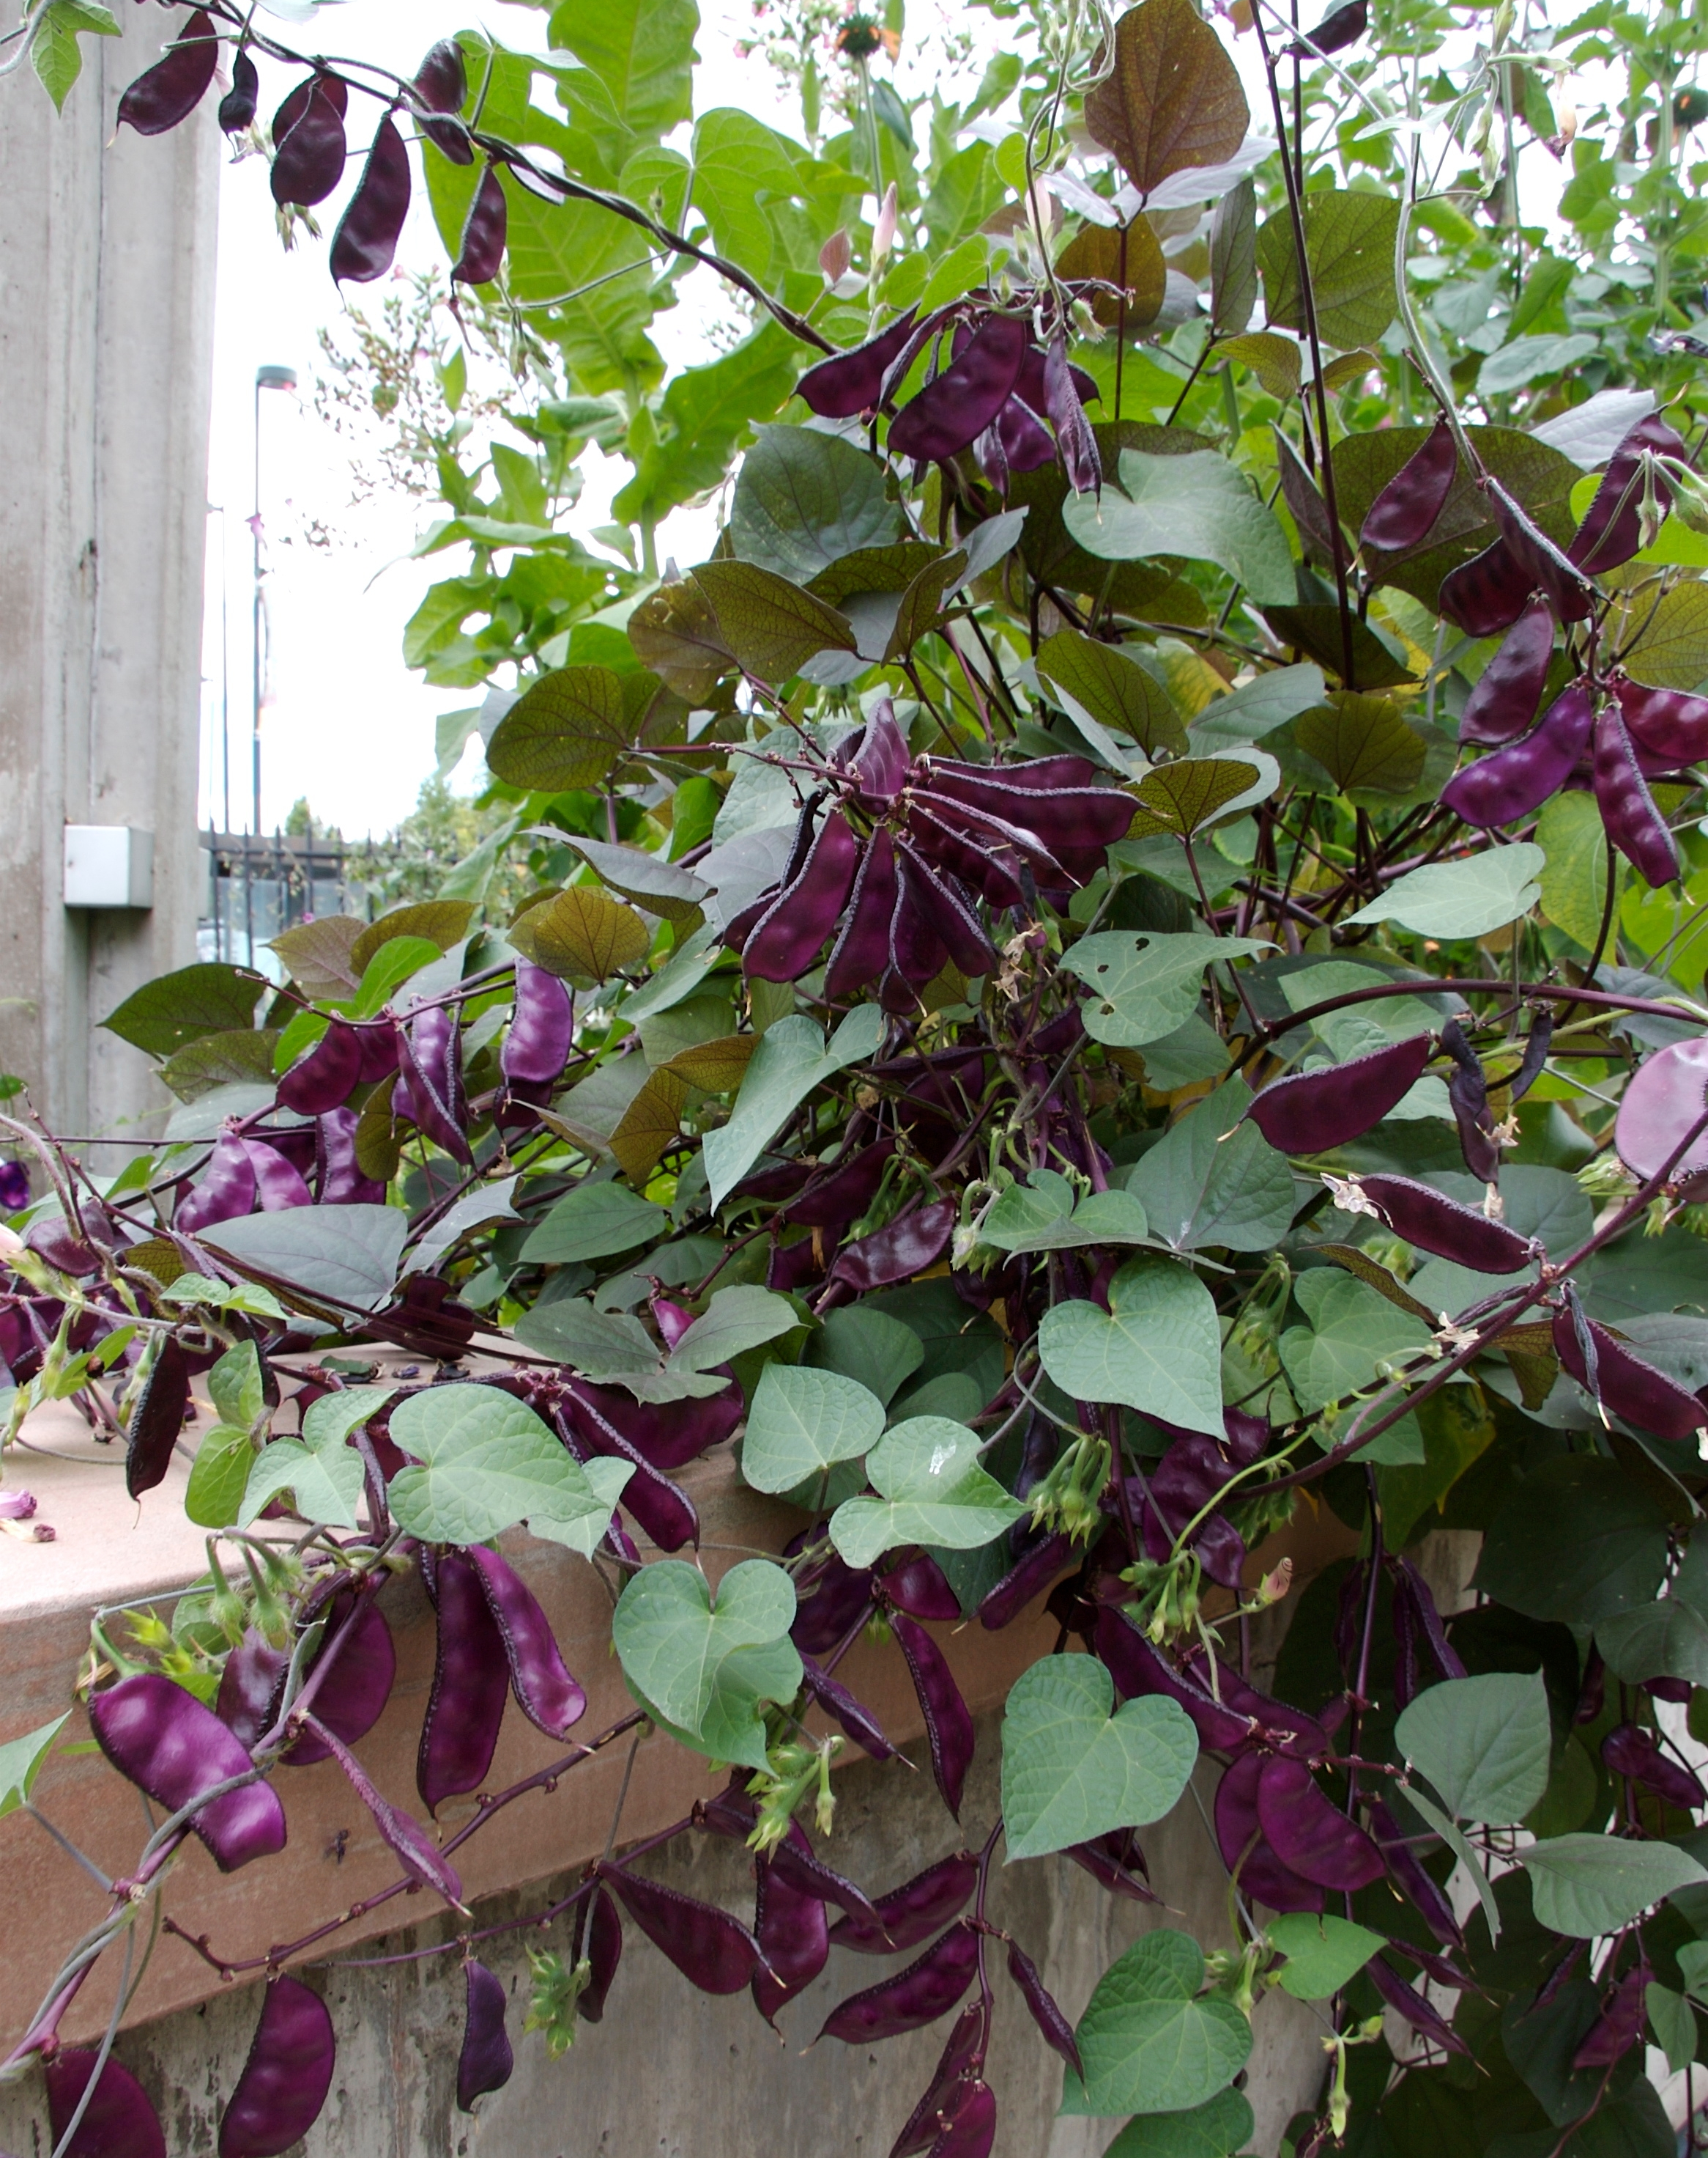
Height: 6-10’ trellised
Width: 3-5’ un-trellised
Blooms: Late spring to frost
Sun: Full sun to partial shade
Water: Moderate
Hardiness: USDA zones 7 and warmer; annual elsewhere
Culture: Average soil
Introduced: 2006
Edible Vine
A vigorous mounding vine with dark burgundy foliage, amethyst flowers and showy dark violet bean pods in late summer. Very desirable annual for cold climates. Excellent in containers. Perennial in the South.

Ruby Moon Hyacinth Bean
Dolichos lablab ‘Ruby Moon’
www.plantselect.org

