


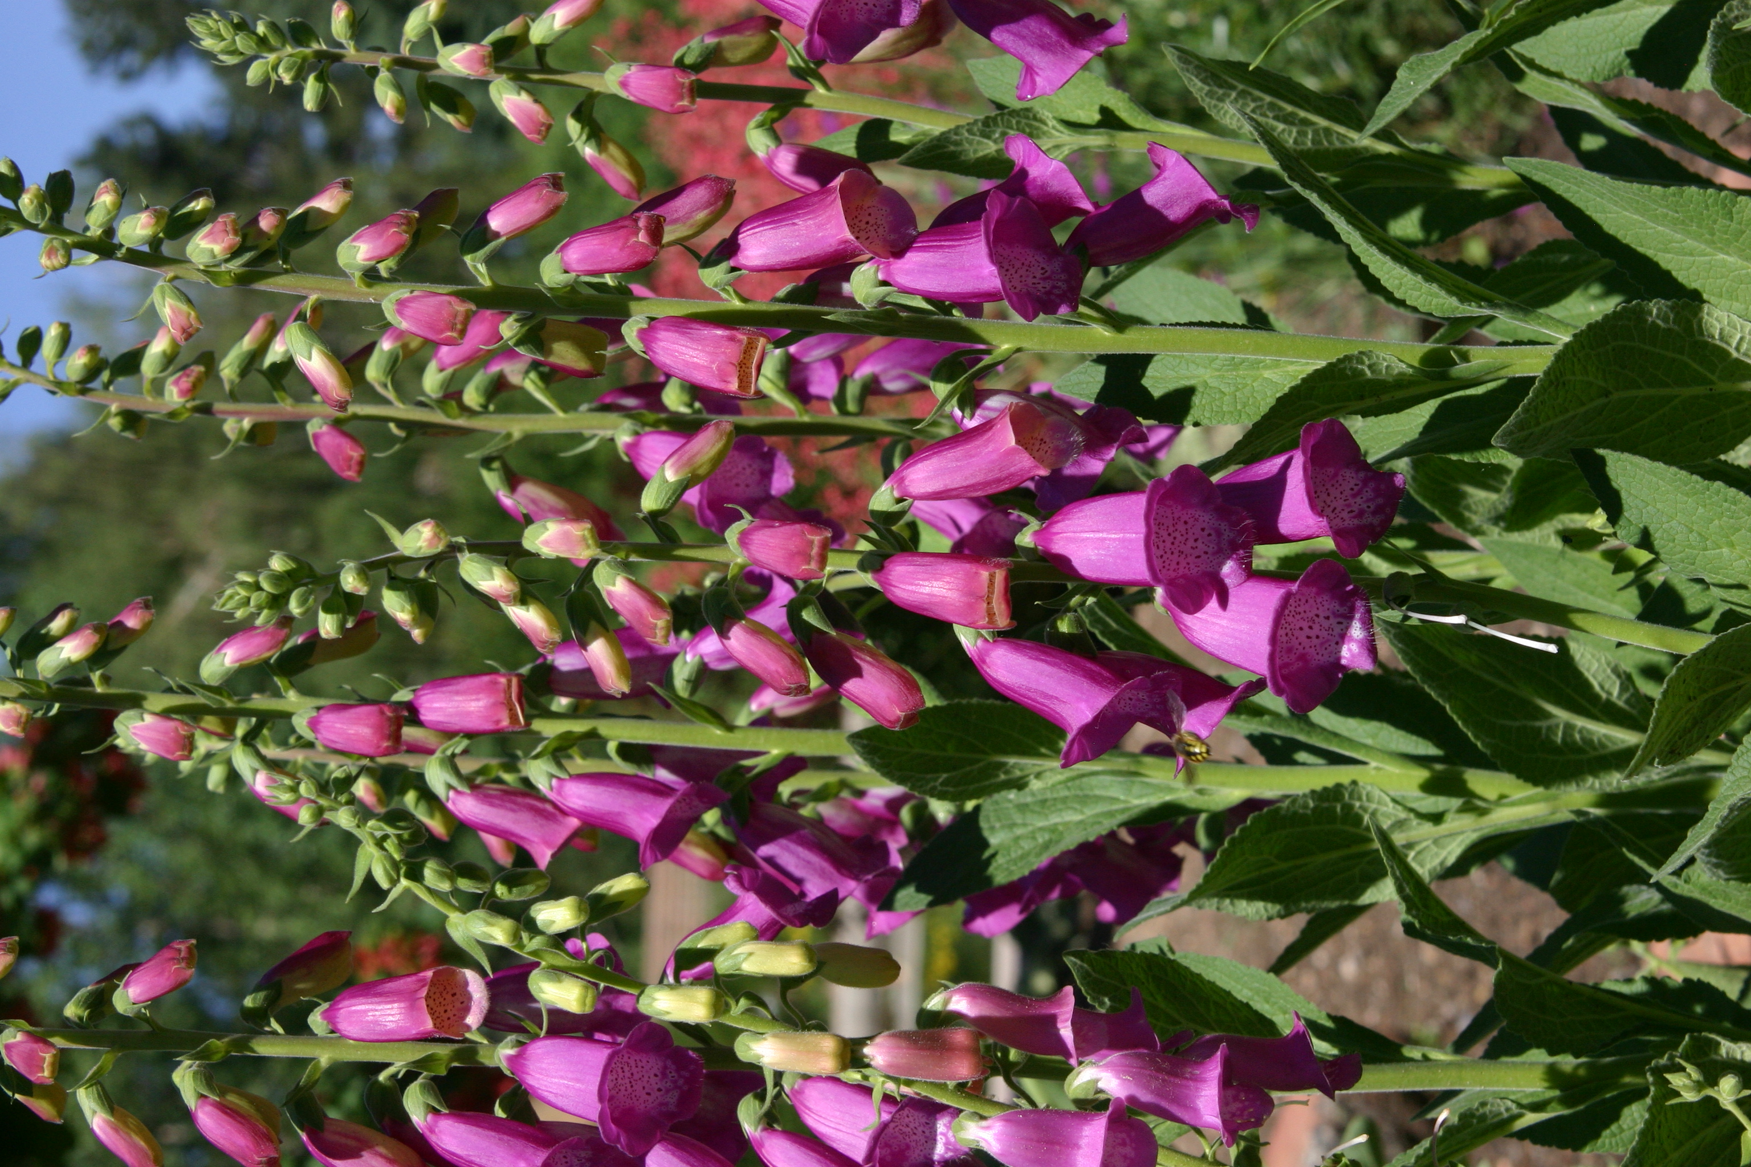
Height: 12”
Width: 12”
Blooms: Early summer
Sun: Full sun to partial shade
Water: Moderate
Hardiness: USDA zones 4b-9
Culture: Average soil
Introduced: 1999
Perennial
Raspberry rose-colored flowers in early summer are carried over a trim mat of furry leaves. This cousin to the familiar foxglove is perennial, and virtually unknown in cultivation. Thrives in a variety of sites and soils. From Spain.

Spanish Peaks® Foxglove
Digitalis thapsi
www.plantselect.org

