


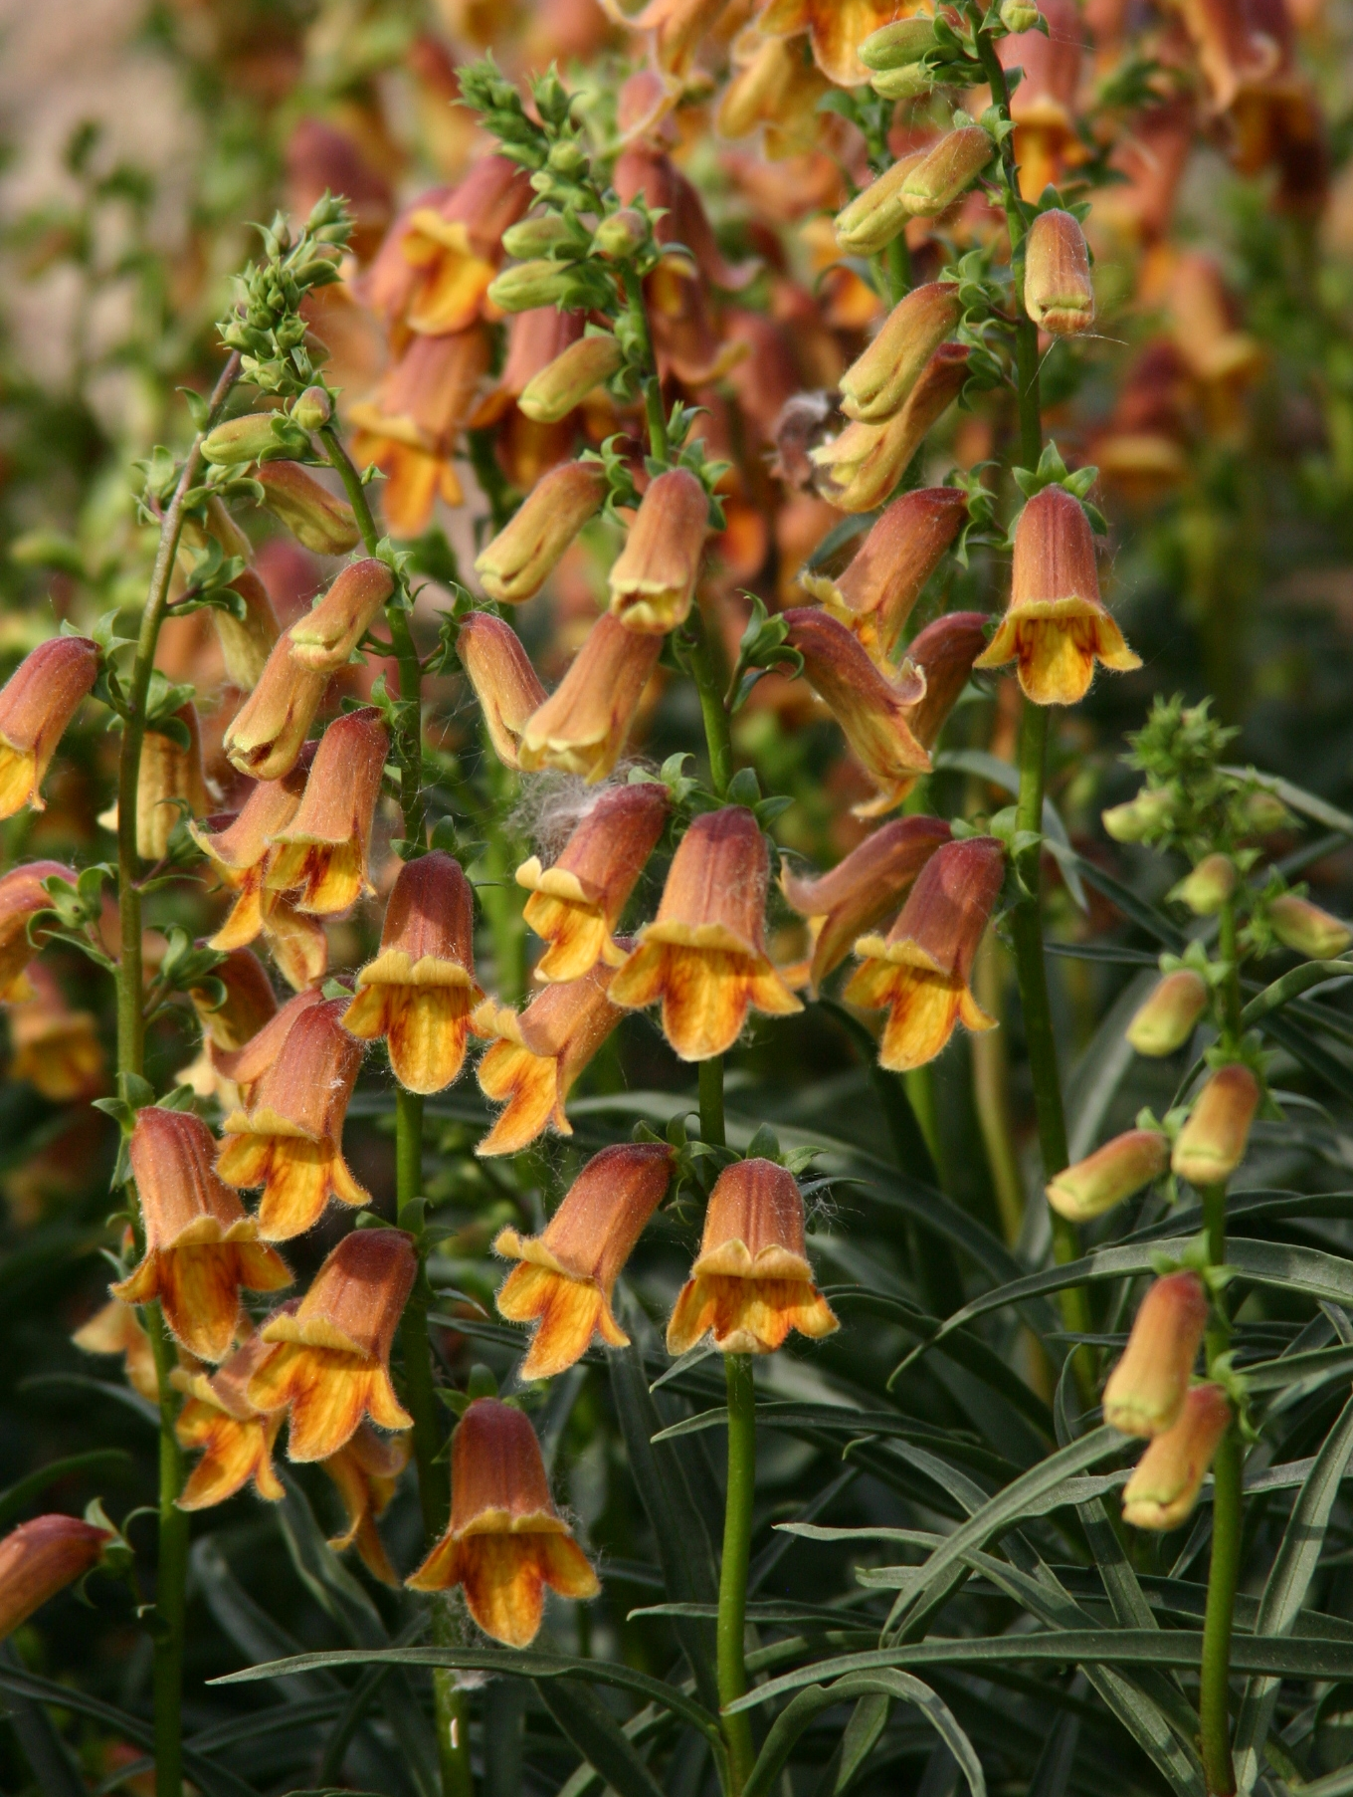
Height: 14-24”
Width: 15-20”
Blooms: Summer to fall
Sun: Full sun to partial shade
Water: Moderate to dry
Hardiness: USDA zones 5-9
Culture: Average, clay, or sandy soil
Introduced: 2004
Perennial
Dwarf selection with evergreen, willow-like foliage that is set off by burnt sienna-colored trumpet shaped flowers.

Sunset® Foxglove
Digitalis obscura
www.plantselect.org

