


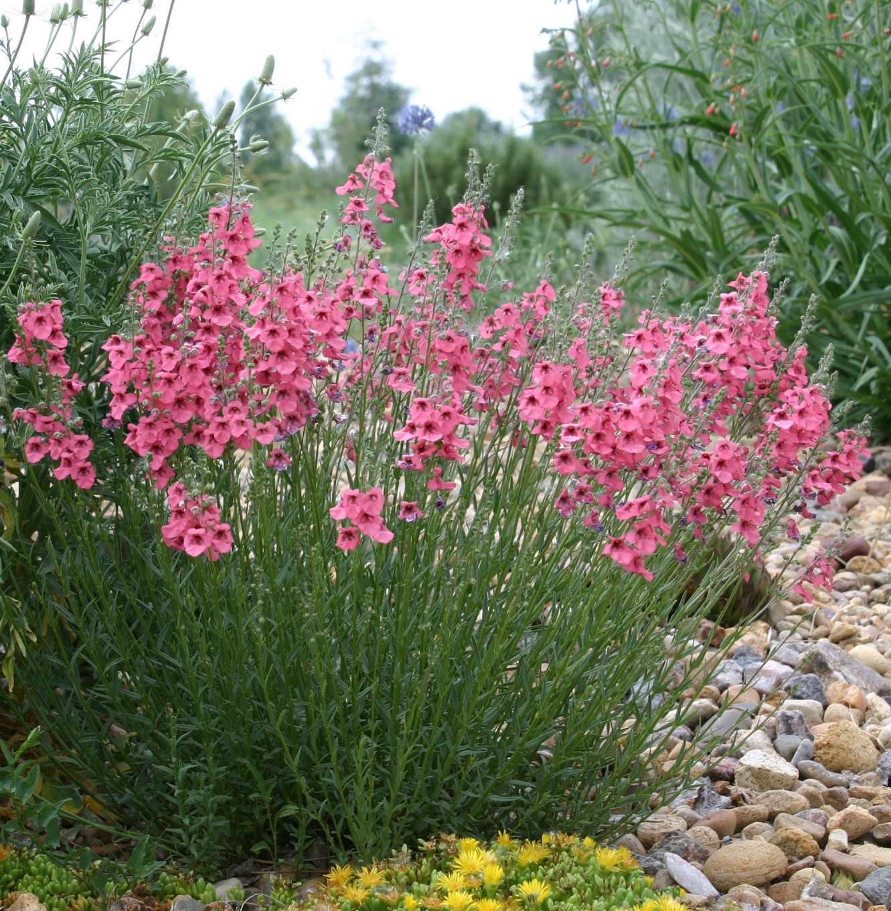
Height: 15”
Width: 12”
Blooms: Late spring to frost
Sun: Full sun to partial shade
Water: Moderate
Hardiness: USDA zones 4b-8
Culture: Average soil
Introduced: 2000
Perennial
A cloud of soft pink, oval flowers from late spring to autumn frost. This heat tolerant introduction from the East Cape Drakensberg Range of South Africa has a wide tolerance of soil and exposure. By far the toughest performer in this novel genus of everblooming wildflowers.

Coral Canyon® Twinspur
Diascia integerrima
www.plantselect.org

