
Table Mountain® Ice Plant
Delosperma ‘John Proffitt’


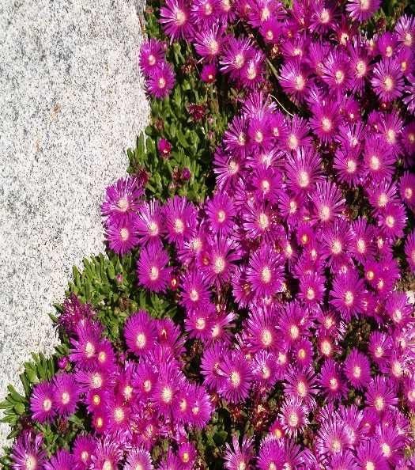






Height: 2 in. Width: 16-20 in.
A fast spreading ground cover from South Africa that blooms for most of the growing season. The lustrous, fuchsia flowers are an improvement on Delosperma cooperi. During the winter the leaves remain turgid and green, often tinged with purple.
Culture: Clay, loam or sandy soil
Hardiness: USDA zones 4-9



WIND. HAIL. SNOW. SUN
BRING IT ON

www.plantselect.org



