

**Table Mountain® Ice Plant**

*Delosperma* ‘John Proffitt’

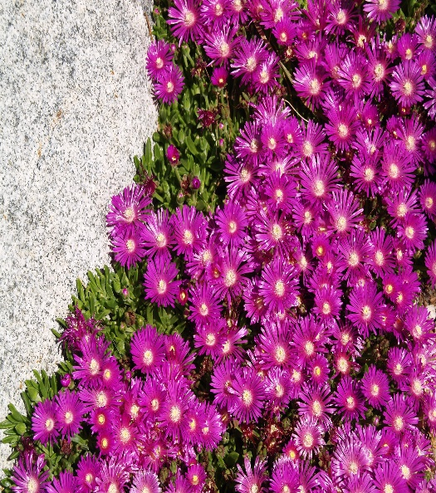

**Height: 2 in. Width: 16-20 in.**

A fast spreading ground cover from South Africa that blooms for most of the growing season. The lustrous, fuchsia flowers are an improvement on *Delosperma cooperi*. During the winter the leaves remain turgid and green, often tinged with purple.

**Culture:** Clay, loam or sandy soil

**Hardiness:** USDA zones 4-9



WIND. HAIL. SNOW. SUN

**BRING IT ON**

www.plantselect.org

