
Starburst® Ice Plant
Delospermum floribundum







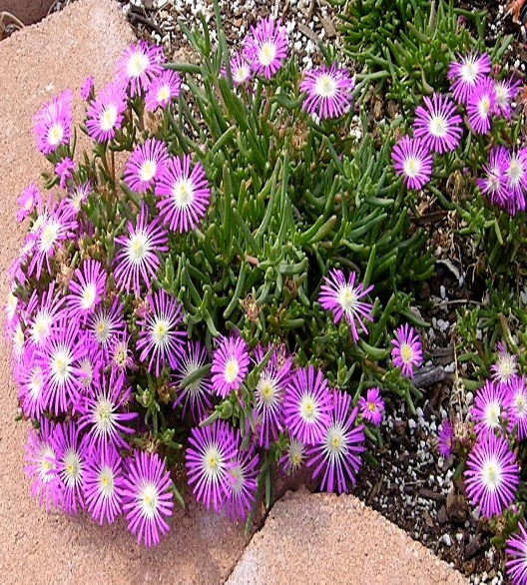

Height: 4 in. Width: 8-12 in.
This clumping ice plant produces a dome of bright pink flowers with white centers. The texture of the petals is shimmering – almost like metal. It starts blooming in June, and continues until fall. It promises to be an essential small scale groundcover or edging for the border.
Culture: Loam or sandy soil
Hardiness: USDA zones 5-9



WIND. HAIL. SNOW. SUN
BRING IT ON

www.plantselect.org



