

**Starburst® Ice Plant**

*Delospermum floribundum*

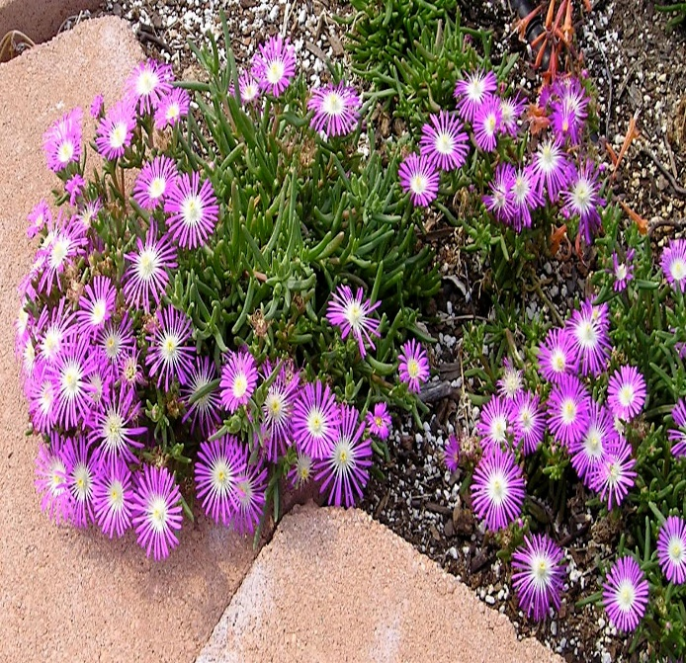

**Height: 4 in. Width: 8-12 in.**

This clumping ice plant produces a dome of bright pink flowers with white centers. The texture of the petals is shimmering – almost like metal. It starts blooming in June, and continues until fall. It promises to be an essential small scale groundcover or edging for the border.

**Culture:** Loam or sandy soil

**Hardiness:** USDA zones 5-9



WIND. HAIL. SNOW. SUN

**BRING IT ON**

www.plantselect.org

