

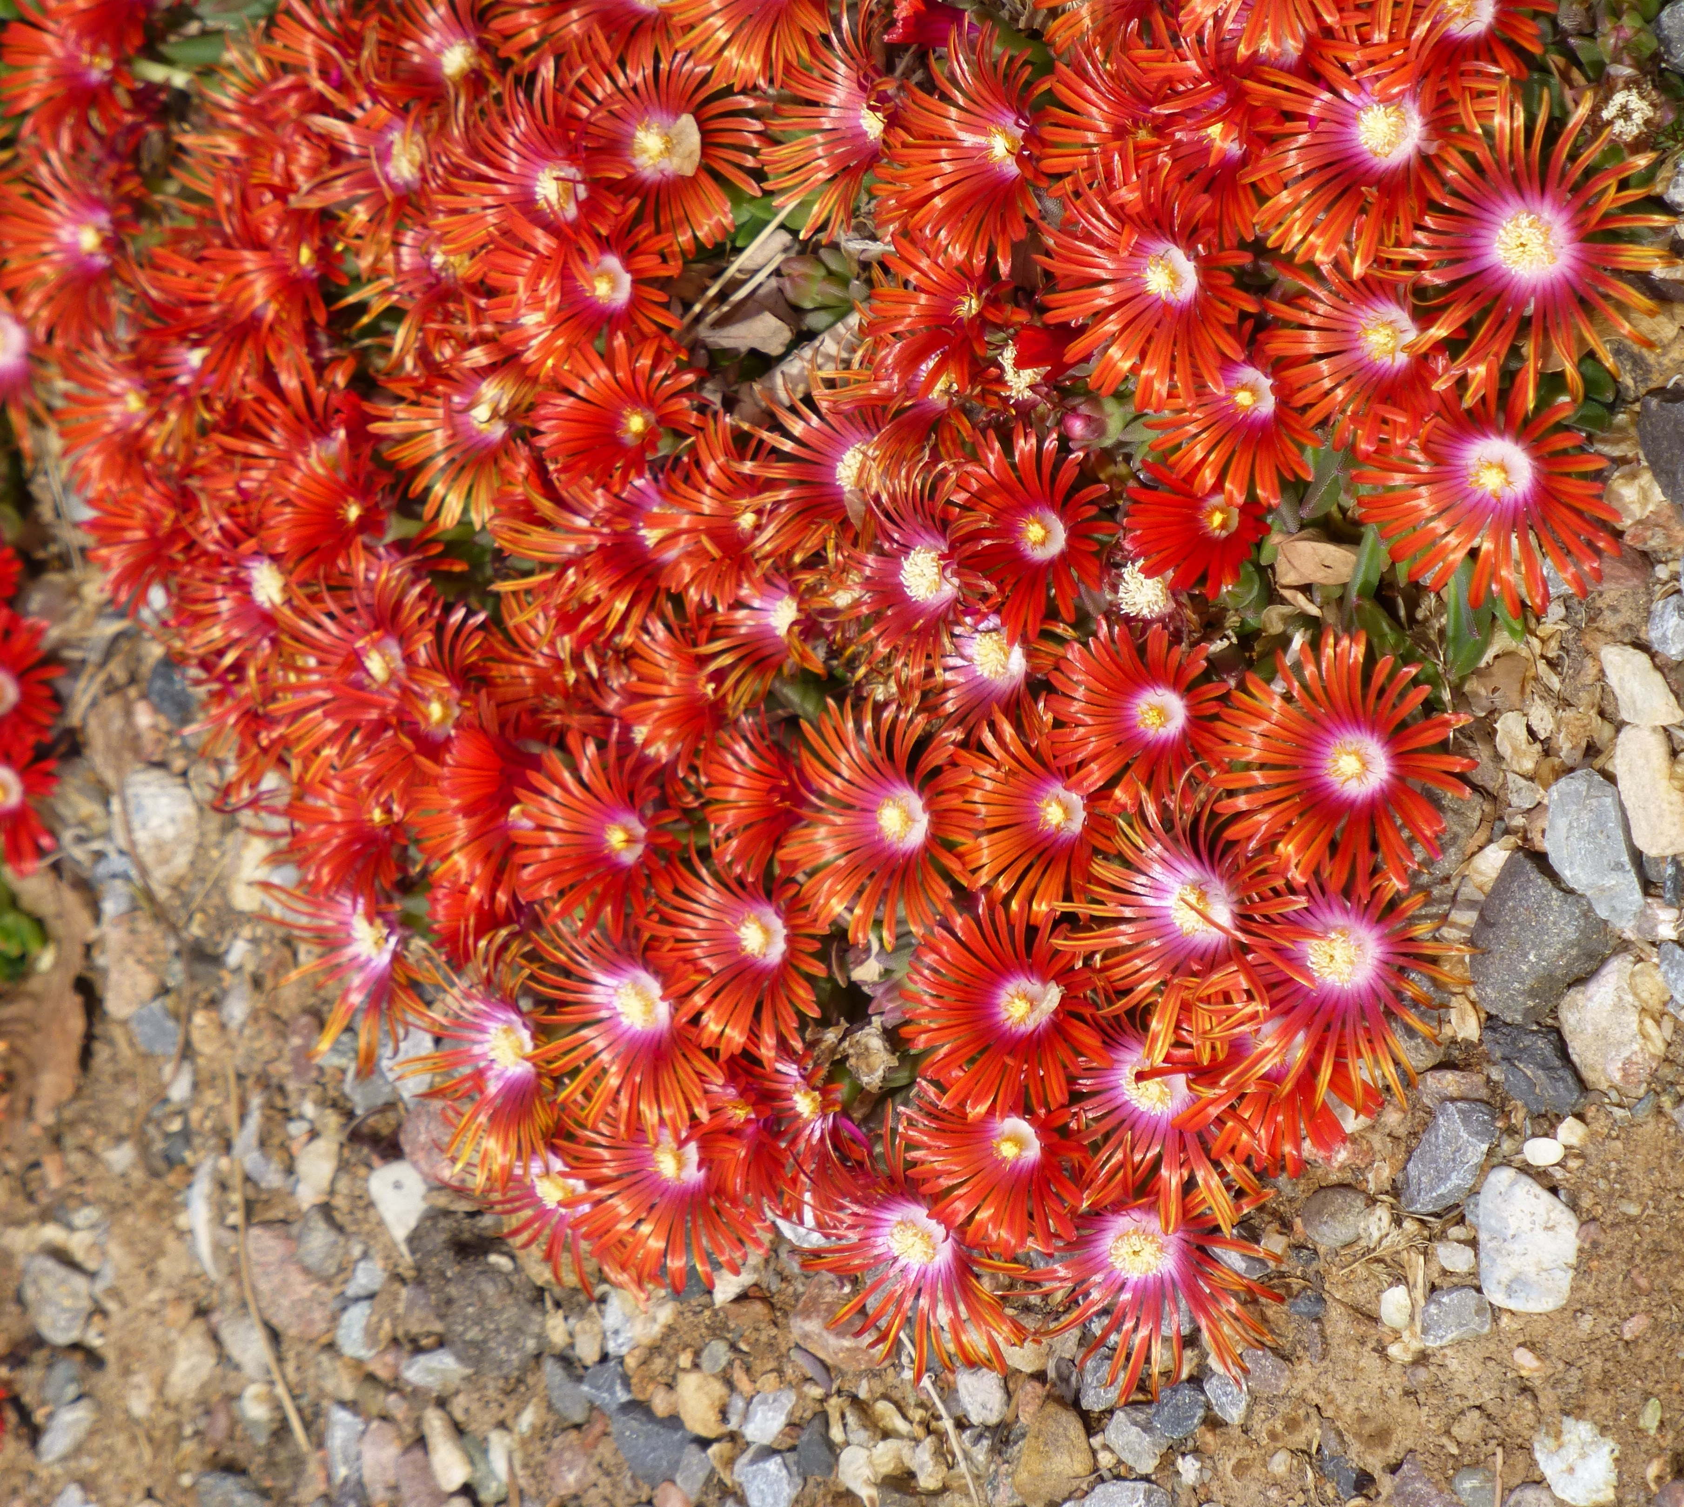






Height: 2”
Width: 24”
Blooms: Late spring and early summer
Sun: Full sun to partial shade
Water: Moderate to xeric
Hardiness: USDA zones 4-9
Culture: Adaptable
Introduced: 2016
Perennial groundcover
This new hybrid selection is a tough, vigorous cold-hardy form with large, blazing orange-red flowers in late spring and early summer. Its small, deep green, succulent leaves are evergreen. Selected for superior flower size (nearly 2” wide), unusual flower color and attractive habit from an evaluation plot of seedlings by David Salman, Santa Fe, NM.

Red Mountain® Flame ice plant
Delosperma ‘PWWG02S’
www.plantselect.org

