

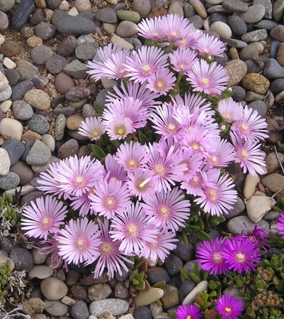
Height: 2-3”
Width: 1-2’
Blooms: May to September
Sun: Full sun to partial shade
Water: Moderate to dry
Hardiness: USDA zones 4-9 (up to 7,000’)
Culture: Clay, sandy, or loamy soil
Introduced: 2009
Perennial
A fantastic color breakthrough in ice plants! Iridescent lavender with a dark eye, this striking sport of Table Mountain® occurred at Perennial Favorites nursery in Rye, Colorado. Trim green mats purplish in winter.

Lavender Ice Ice Plant
Delosperma ‘Psfave’
www.plantselect.org

