

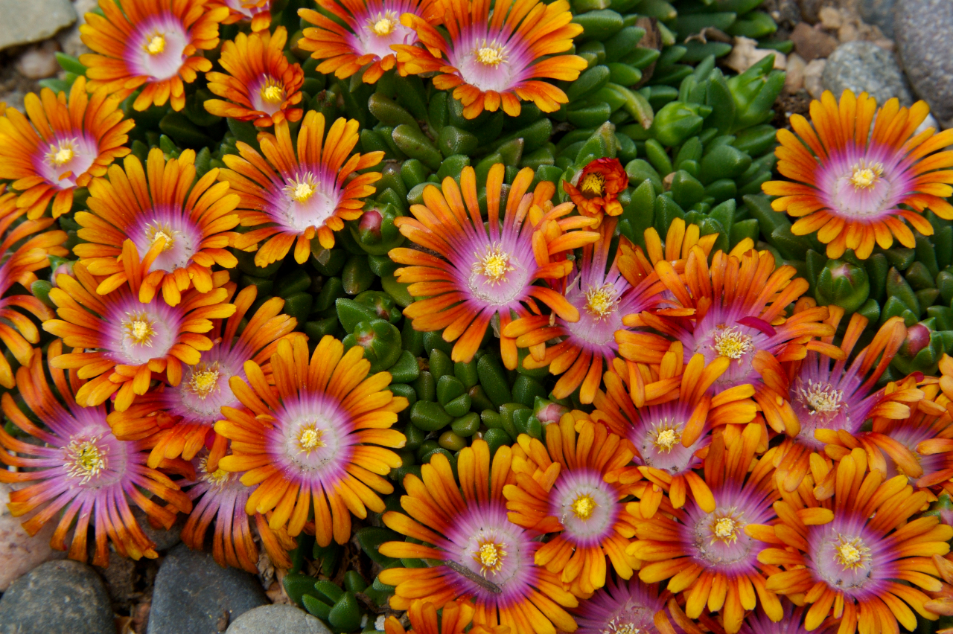
Height: 1-2”
Width: 12-18”
Blooms: April to June
Sun: Full sun to partial shade
Water: Moderate to xeric
Hardiness: USDA zones 5-10 (up to 6,000’)
Culture: Sandy loam soil
Introduced: 2012
Perennial Groundcover
This shocking color combination of the individual flowers represents a dramatic color breakthrough for the hardy ice plants. The green-apple foliage makes a glistening, fast spreading carpet that keeps its shiny presence through winter. The flowers are massed in spring, but reappear periodically through the summer. This unique cultivar traces its ancestry to the Eastern Cape of South Africa.

Fire Spinner® Ice Plant
Delosperma ‘P001S’
www.plantselect.org

